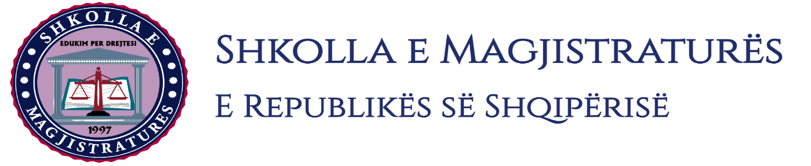

THE SCHOOL OF MAGISTRATES
OF THE REPUBLIC OF ALBANIA

IInd year
2023-2024

CIVIL MOCK TRIAL

On 2 February, 2024, candidates for magistrate of the second year, under the mentorship of Prof. Dashamir Kore, organized the mock trial in civil law. The case chosen by the candidates was:

“Compensation for property and non-property damage (in the form of biological, moral and existential damage) and the violation of the right to private and family life.”

In the chosen case, candidates elaborated legal issues related to the nature of the compensation of property and non-property damage (in the form of biological, moral and existential damage); cumulative criteria that have to be met so that to exist the responsibility for damage compensation (systematic interpretation of the Articles 608 and 609 of the Civil Code); active legitimating in this type of trial; burden of proof; the violation of the right for private and family life because of the violation of the principle of confidentiality; judicial debate on evidences and the taking of electronic proofs from the court. In simulation, candidates made part of their analysis considering also the debate on the recent jurisprudence of the High Court on legal issues brought for analysis.

The mock trial, in all its phases, applied procedural rules sanctioned in the Code of Civil Procedures as well as respected the solemnity of the trial.

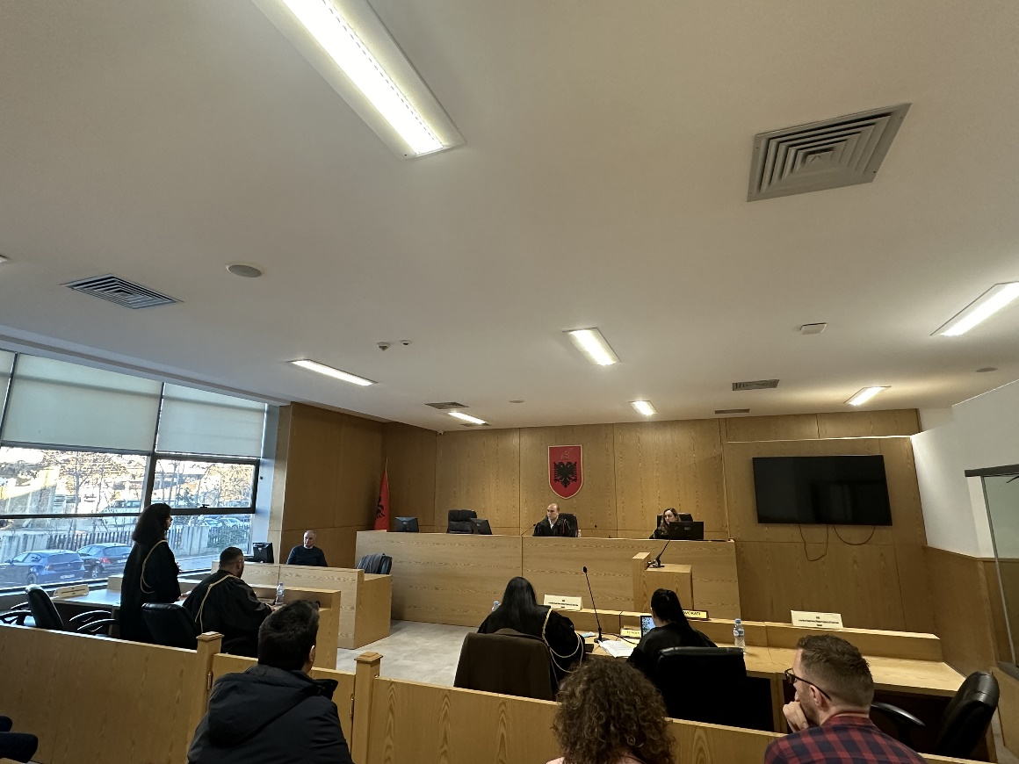
Photo of the mock trial, IInd year

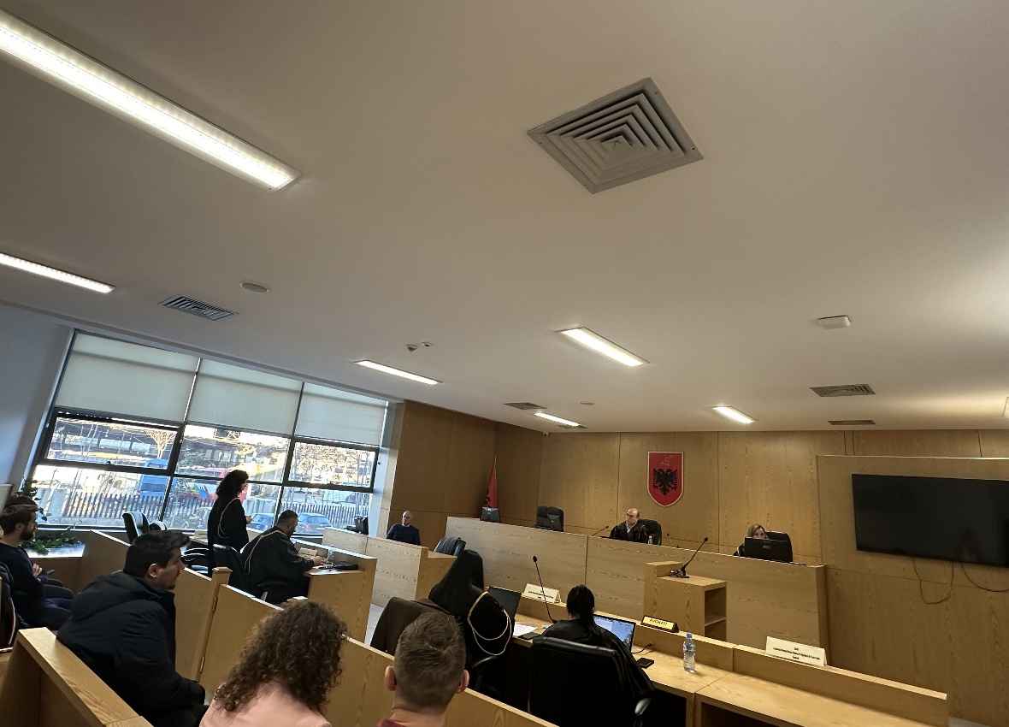
Photo of the mock trial, IInd year

