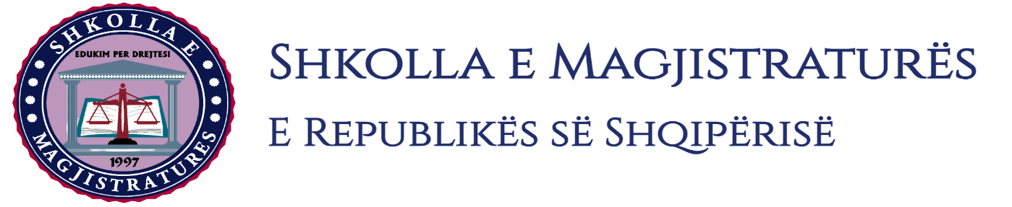

THE SCHOOL OF MAGISTRATES
OF THE REPUBLIC OF ALBANIA

IInd year
2023-2024

CIVIL MOCK TRIAL

On 4 April, 2024, candidates for magistrate of the second year, under the mentorship of lecturer Dashamir Kore, organized the third mock trial in civil law. The case chosen by the candidates was:

“The obligation of the defendant, to pay to the plaintiff, the amount of 100.000 lekë, as the main obligation and late interests up to the execution of the obligation. The obligations of the defendant to pay to the plaintiff the legal expenses under the law. Legal basis Articles 419, 422, 455, 459, 463, 467, 481 as well as Articles 659 and Articles 1074 of the Civil Code, Articles 32, 35, 41, 42 of the Code of Civil Procedure.”

In this mock trial, candidates for magistrates elaborated different procedural topics as follows:
- Application of lawsuit:
- Application for exclusion from judicial fees;
- Notification of the defense declaration;

- On the notification of the lawsuit request and evidences;
- Notification of the application for essential interference;
- The nomination of the expert and the making of preliminary actions from the judge of the preparatory session in the judicial session discussions of parties on the object of the lawsuit;
- Discussion on evidences, as well as final conclusions regarding the claims of parties in process.

Mock trial, in all its phases, applied procedural rules sanctioned in the Code of Civil Procedure, as well as respected the solemnity of the trial.

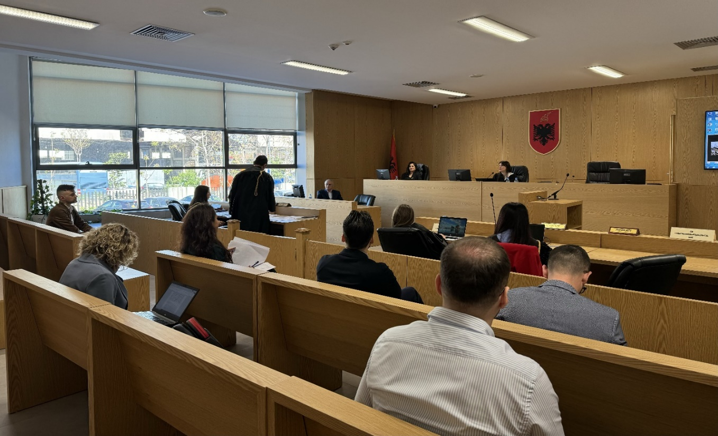
Photo of the mock trial, IInd year
