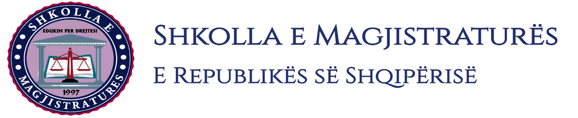

THE SCHOOL OF MAGISTRATES
OF THE REPUBLIC OF ALBANIA

IInd year
2023-2024

CIVIL MOCK TRIAL

On 05 February, 2024, candidates for magistrate of the second year, under the mentorship of Prof. Dashamir Kore, organized the mock trial in civil law. The case chosen by the candidates was:

“The declaration of the invalidity of the registration of the trademark and its deregistration, prohibition of the further use of this trademark, compensation for the damage caused because of unfair competition from the use of the trademark.”

In the chosen case, candidates elaborated procedural aspects such as the lack of the jurisdiction of the Albanian court, the lack of passive legitimating, the non-correct formation of litigation for the call of the third person, res iudicata, the opposition of the form of the electronic evidence, etc. Were elaborated material aspects such as the invalidity of trademark registration, the elements of the well-known trademark, bad faith, lawsuit prescription, damage reward because of unfair competition, the evidencing force of the electronic evidence, application to file a new proof in the judicial hearing, the opposition of the expertise act, specifying the object of the lawsuit, etc.

The mock trial, in all its phases, applied procedural rules sanctioned in the Code of Civil Procedures as well as respected the solemnity of the trial.

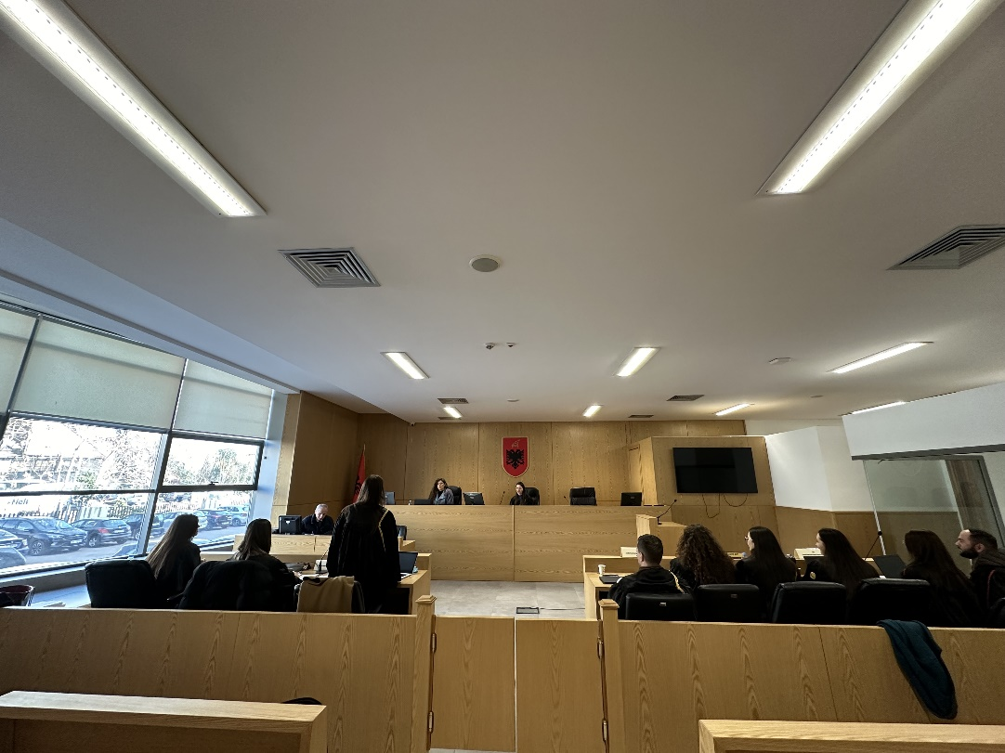
Photo of the mock trial, IInd year

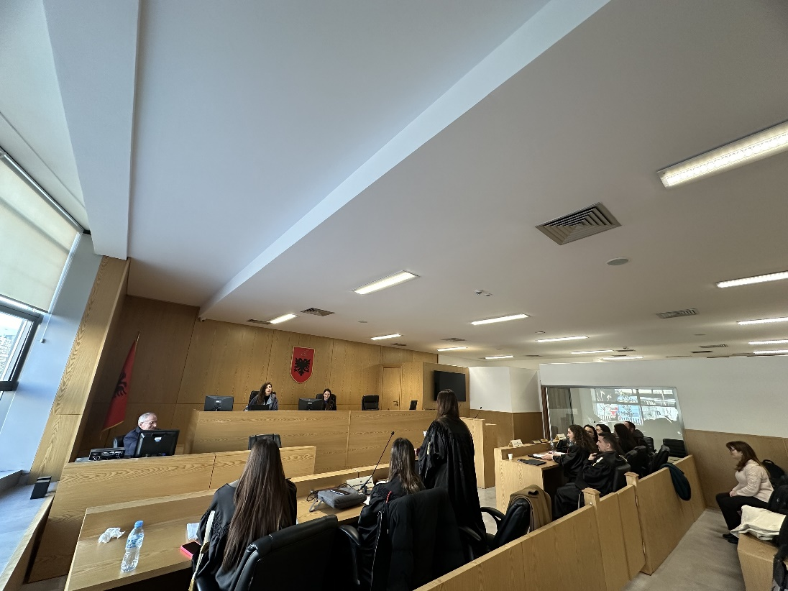
Photo of the mock trial, IInd year

