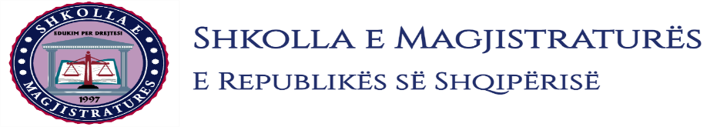

THE SCHOOL OF MAGISTRATES
OF THE REPUBLIC OF ALBANIA

IInd year
2023-2024

CIVIL MOCK TRIAL

On 06 November, 2023, candidates for magistrate of the second year, under the mentorship of Prof. Vangjel Kosta, organized the civil mock trial. The case chosen by the candidates was:

“The sharing of property according to the parts of each co-owner.”

In this mock trial, candidates for magistrate elaborated different issues of civil procedural law and of the civil material law, such as the main interference and counter claim, the first phase of the sharing of property, the difference between the making of the in effect sentence and the second phase of the sharing of property, where in all phases of this mock trial were respected the rules foreseen by the Code of Civil Procedure on the completion of the judicial process. All members of the group demonstrated respect for the solemnity of the trial
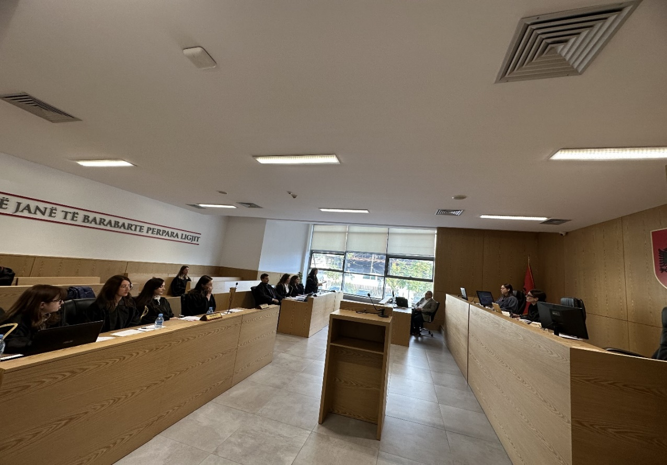

Photo of the mock trial, IInd year

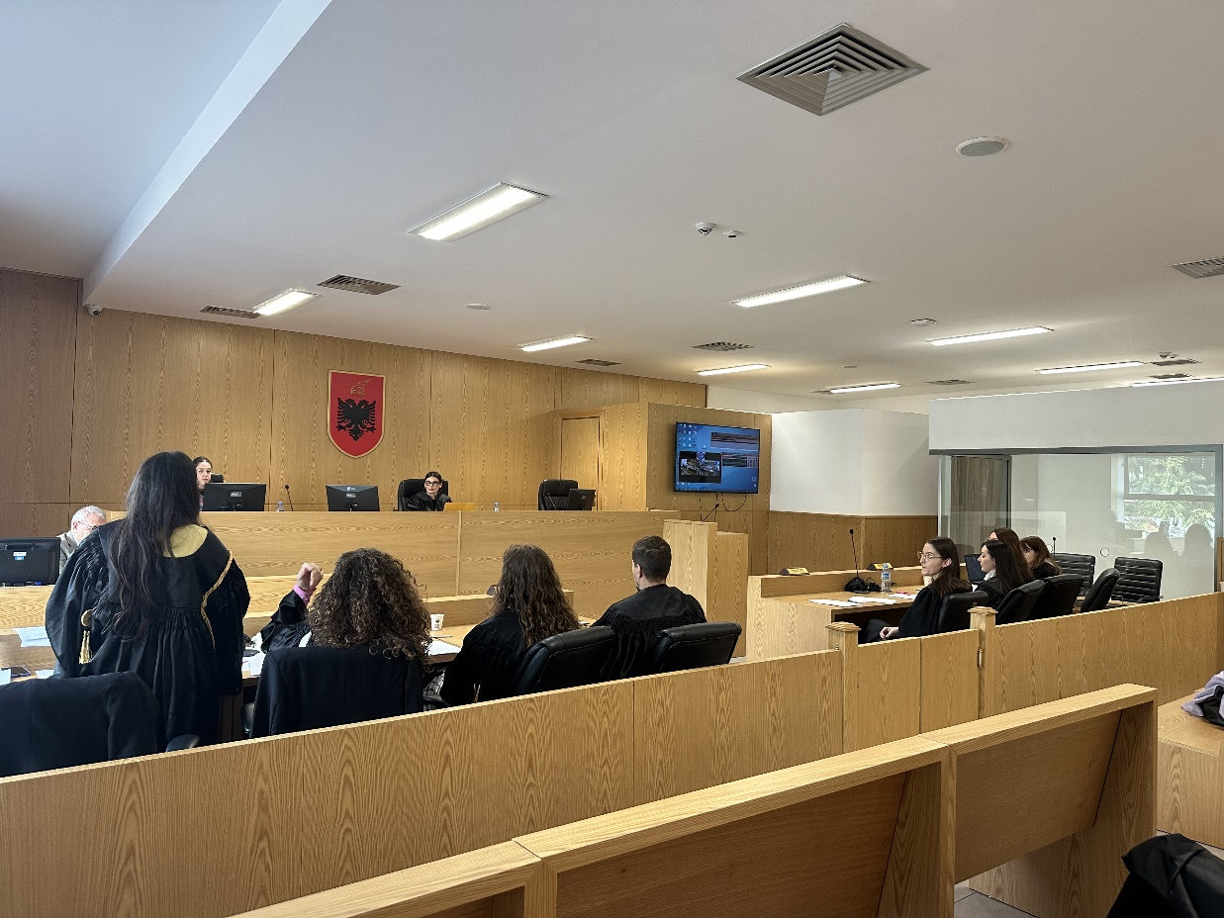

Photo of the mock trial, IInd year

