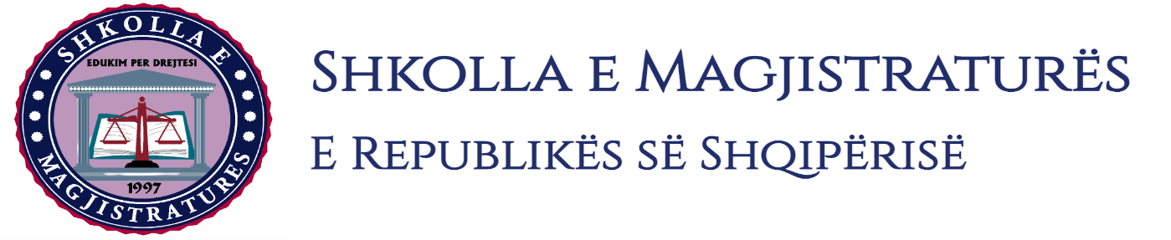

THE SCHOOL OF MAGISTRATES
OF THE REPUBLIC OF ALBANIA

IInd year
2023-2024

CIVIL MOCK TRIAL

On 08 February, 2024, candidates for magistrate of the second year, under the mentorship of Prof.Vangjel Kosta, organized the mock trial in civil law. The case chosen by the candidates was:

“The obligation of the defendants to recognize the plaintiffs as owners,” exclusion of property from sale and sequestration undertaken by the company accused in the context of the compulsory execution of the executive title. The suspension of the execution of the executive title.”

In the chosen case, candidates elaborated procedural aspects such as, the application for the main interference of the third person, formation of litigation, the stay of the trial, the receiving of the proof with expert. In the mock trial were elaborated material aspects such as the invalidity of the enterprise contract, bad faith, interpretation of the contract, debate on paper documents and their evidencing force, the possibility of the taking as proof of an individual act of expertise, the applicable law, legal communion, administration of property in co-ownership, etc.

The mock trial, in all its phases, applied procedural rules sanctioned in the Code of Civil Procedures as well as respected the solemnity of the trial.

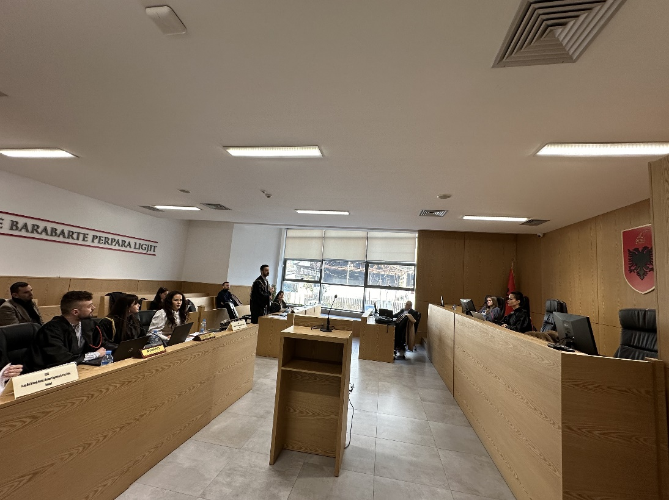
Photo of the mock trial, IInd year

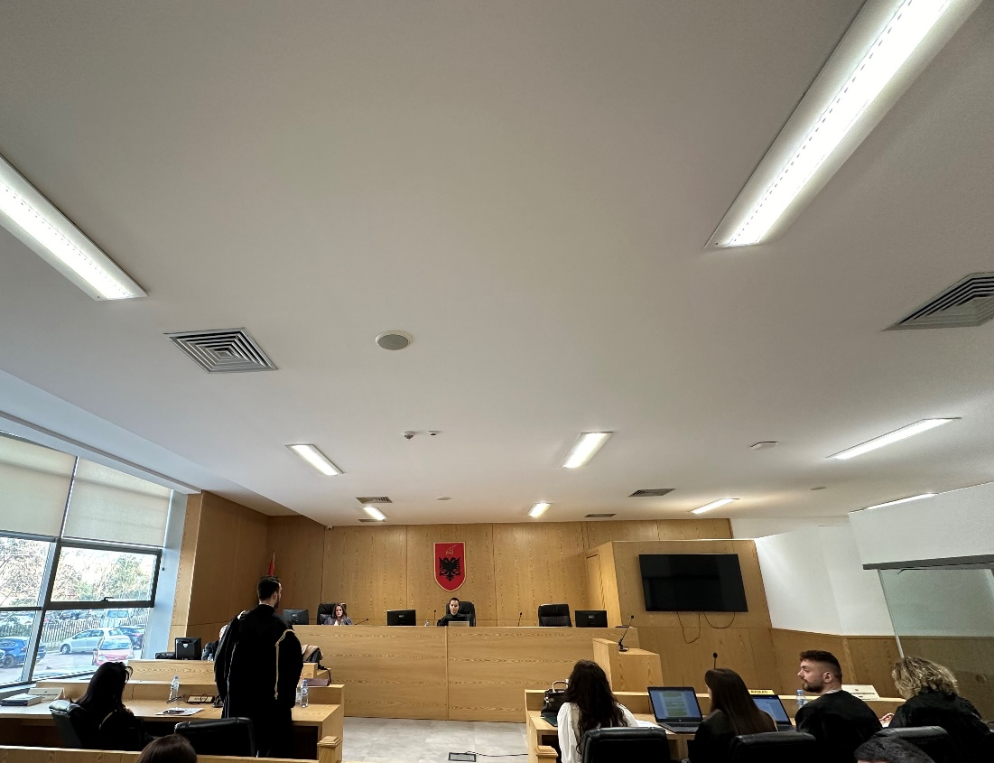
Photo of the mock trial, IInd year

