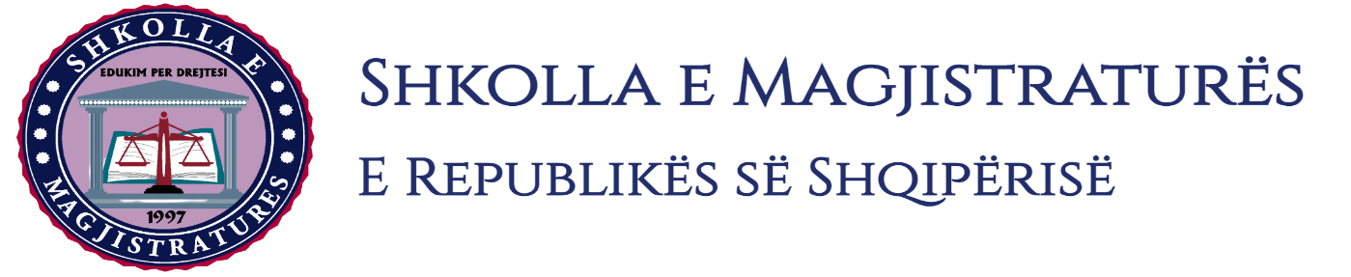

THE SCHOOL OF MAGISTRATES
OF THE REPUBLIC OF ALBANIA

IInd year
2023-2024

CIVIL MOCK TRIAL

On 10 November, 2023, candidates for magistrate of the second year, under the mentorship of the judge Luftie Celami, organized the civil mock trial in civil law. The case chosen by the candidates was:

“The acquisition of property with winning prescription without title, resettlement lawsuit and elements of the legalization process under law no. 20/2020 “on the completion of transitory processes of property in the Republic of Albania.”

In this simulating trial, candidates for magistrate elaborated some institutes of the civil material law and of civil procedure. Also, were elaborated legal conditions that should meet the possessor so that to be considered owner through winning prescription, the interruption of the term of prescription in cases when the owner does not go to the court, but to another institution, calculation of the possession terms, calculation of the term of possession, as well as legal consequences in conditions when the owner of the land has constructed an object which is under the process of legalization.

In all the phases of this mock trial, were respected the rules foreseen by the Code of Civil Procedure regarding the completion of the judicial process. All members of the group respected the solemnity of the trial.

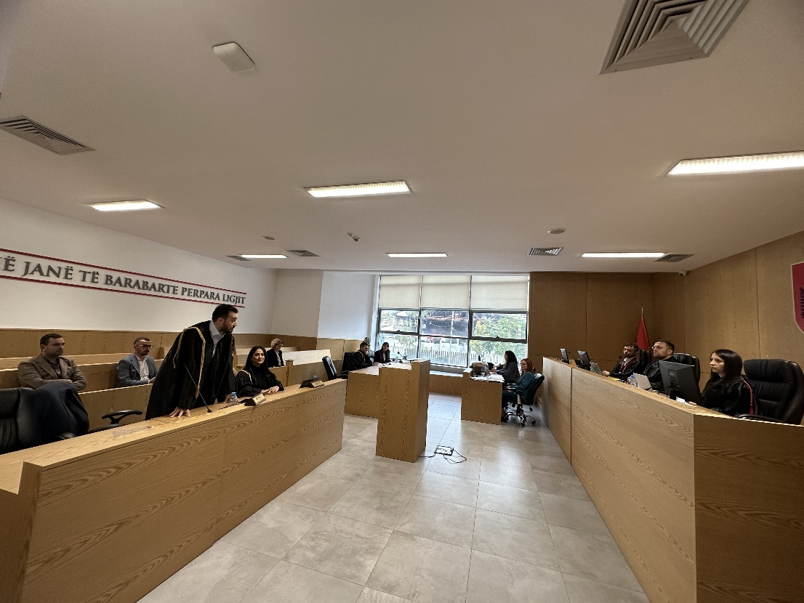
Photo of the mock trial, IInd year

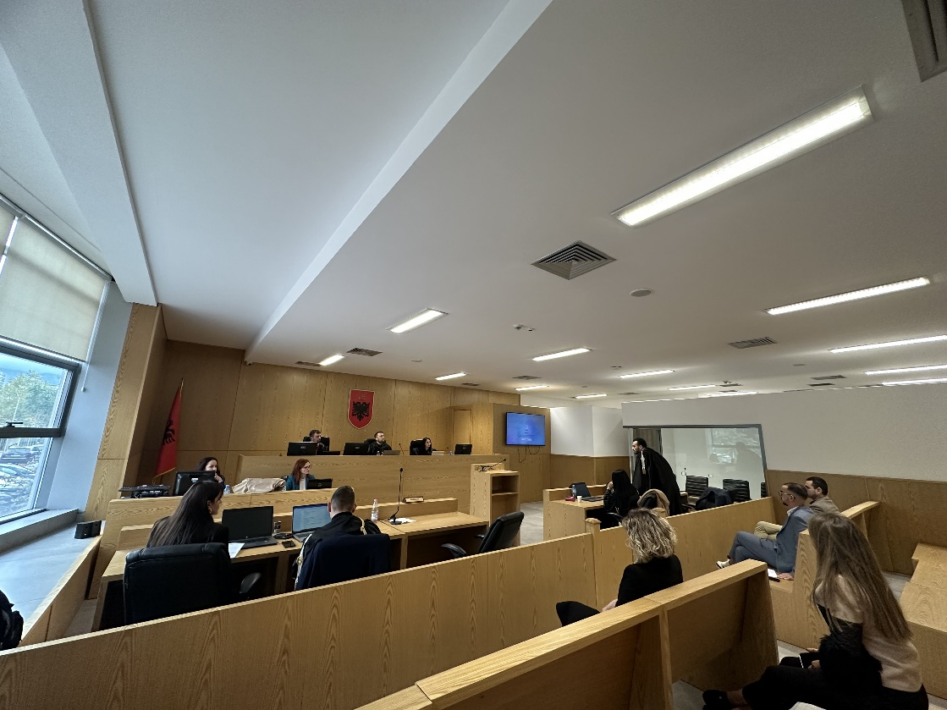
Photo of the mock trial, IInd year

