

THE SCHOOL OF MAGISTRATES
OF THE REPUBLIC OF ALBANIA

IInd year
2023-2024

CIVIL MOCK TRIAL

On 11 December, 2023, candidates for magistrate of the second year, under the mentorship of Prof. Dashamir Kore, organized the civil mock trial. The case chosen by the candidates was:

“Winning prescription with or without title as 2 (two) authentic methods of the winning of property foreseen by the Article 168 and the Article 169 of the Civil Code.”

In this simulating trial, candidates for magistrate elaborated legal issues of civil procedural law and of civil material law, such as:

What are the conditions that have to be met to become an owner with winning prescription with or without title, as the original method to win the ownership?

When the agreement for the alienation of a real estate is under the ownership of an agricultural family and is signed only by its head, is an act that should be prohibited by law or we are in front of an absolute invalidity, considering even the unifying decision no. 393, date 26.10.2022, of the Civil College of the High Court?

When in the composition of an agricultural family there have been minors, are we in front of the suspension of the term of prescription, up to the time when the minor becomes an adult?

The non-receiving of authorization by the court, makes the judicial act relatively or absolutely invalid? Is this relative invalidity covered by the Article 168 of the Civil Code? What is the position of the counter claim in report with the lawsuit, when in the lawsuit is pretended that the plaintiff party has become the owner through the winning prescription with title?

How will be considered and proved the confidence in cases when the dispute is signed only by the head of the agricultural family and the property should be registered so that to be alienated?

Should be received through the winning prescription without title the state property? In a state property to whom is the passive legitimacy? The issuing of the sublegal acts by the state organs brings the interruption of the deadline prescription? Should be exhausted the administrative way in cases of state properties?

The discussion of the proving force of a number of evidences such as the expertise act, witness evidences, notary declarations, as well as other paper acts to prove the quiet and uninterrupted possession as one of the legal conditions foreseen by the Articles 168 and 169 of the Civil Code, to be in front of these methods of the winning of property.

In all the phases of this mock trial, were respected the rules foreseen by the Code of Civil Procedure regarding the completion of the judicial process.

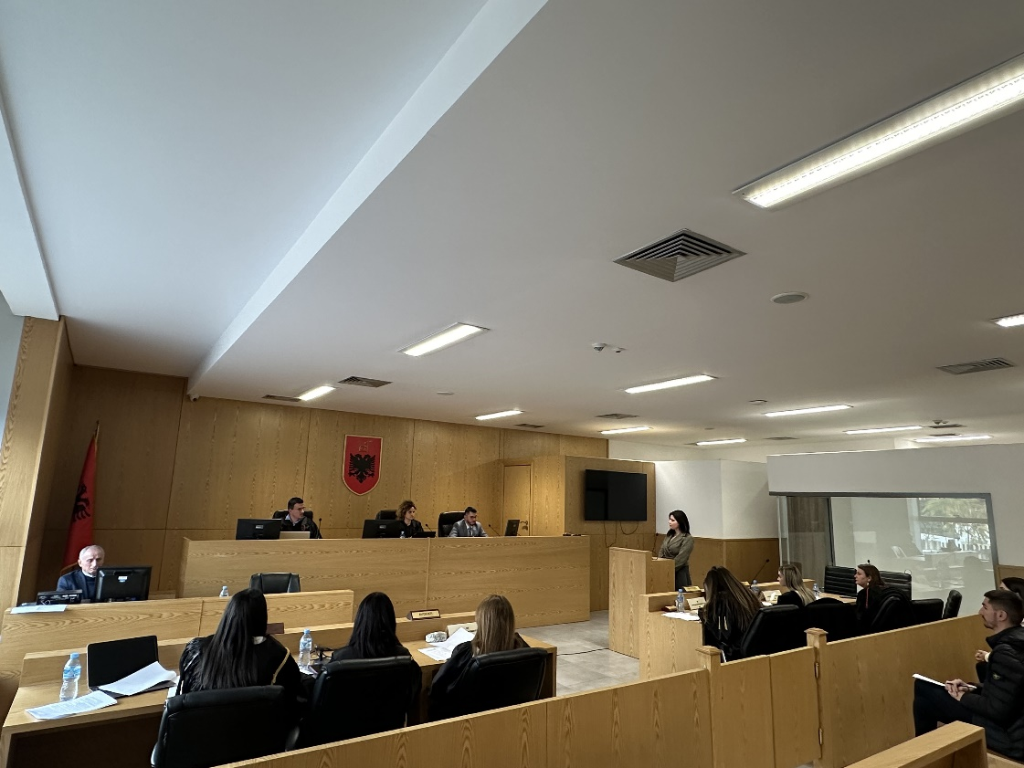
Photo of the mock trial, IInd year

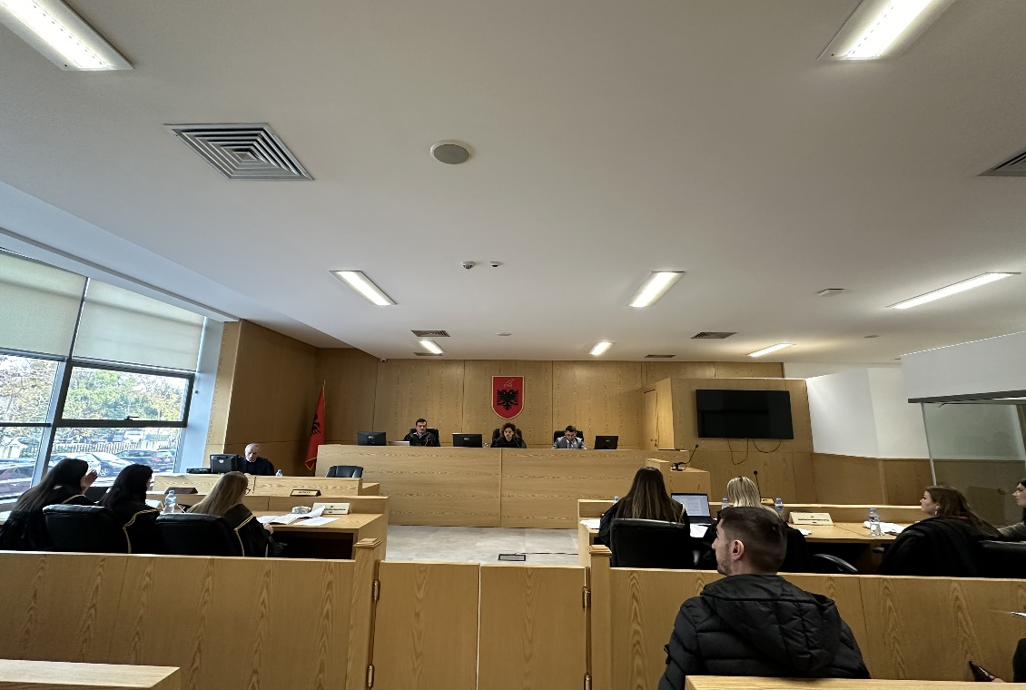
Photo of the mock trial, IInd year

