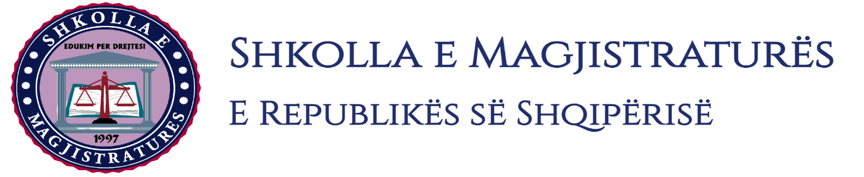
THE SCHOOL OF MAGISTRATES
OF THE REPUBLIC OF ALBANIA

IInd year
2023-2024

CIVIL MOCK TRIAL

On 15 December, 2023, candidates for magistrate of the second year, under the mentorship of Prof. Vangjel Kosta, organized the mock trial in civil law. The case chosen by the candidates was:

“The obligation for recognition as owner, the search of the object by the third person, the exclusion from sequestration and cancellation of mortgage.”

In the chosen case, candidates elaborated different procedural moments of the suspension of execution actions, the claiming of the object by the third person according to the anticipations of the Article 612 of the CCP as well as of the interpretation of the contracts in advance and of the sale of the future item.

The mock trial, in all its phases, applies procedural rules sanctioned in the Code of Civil Procedures as well as respected the solemnity of the trial.

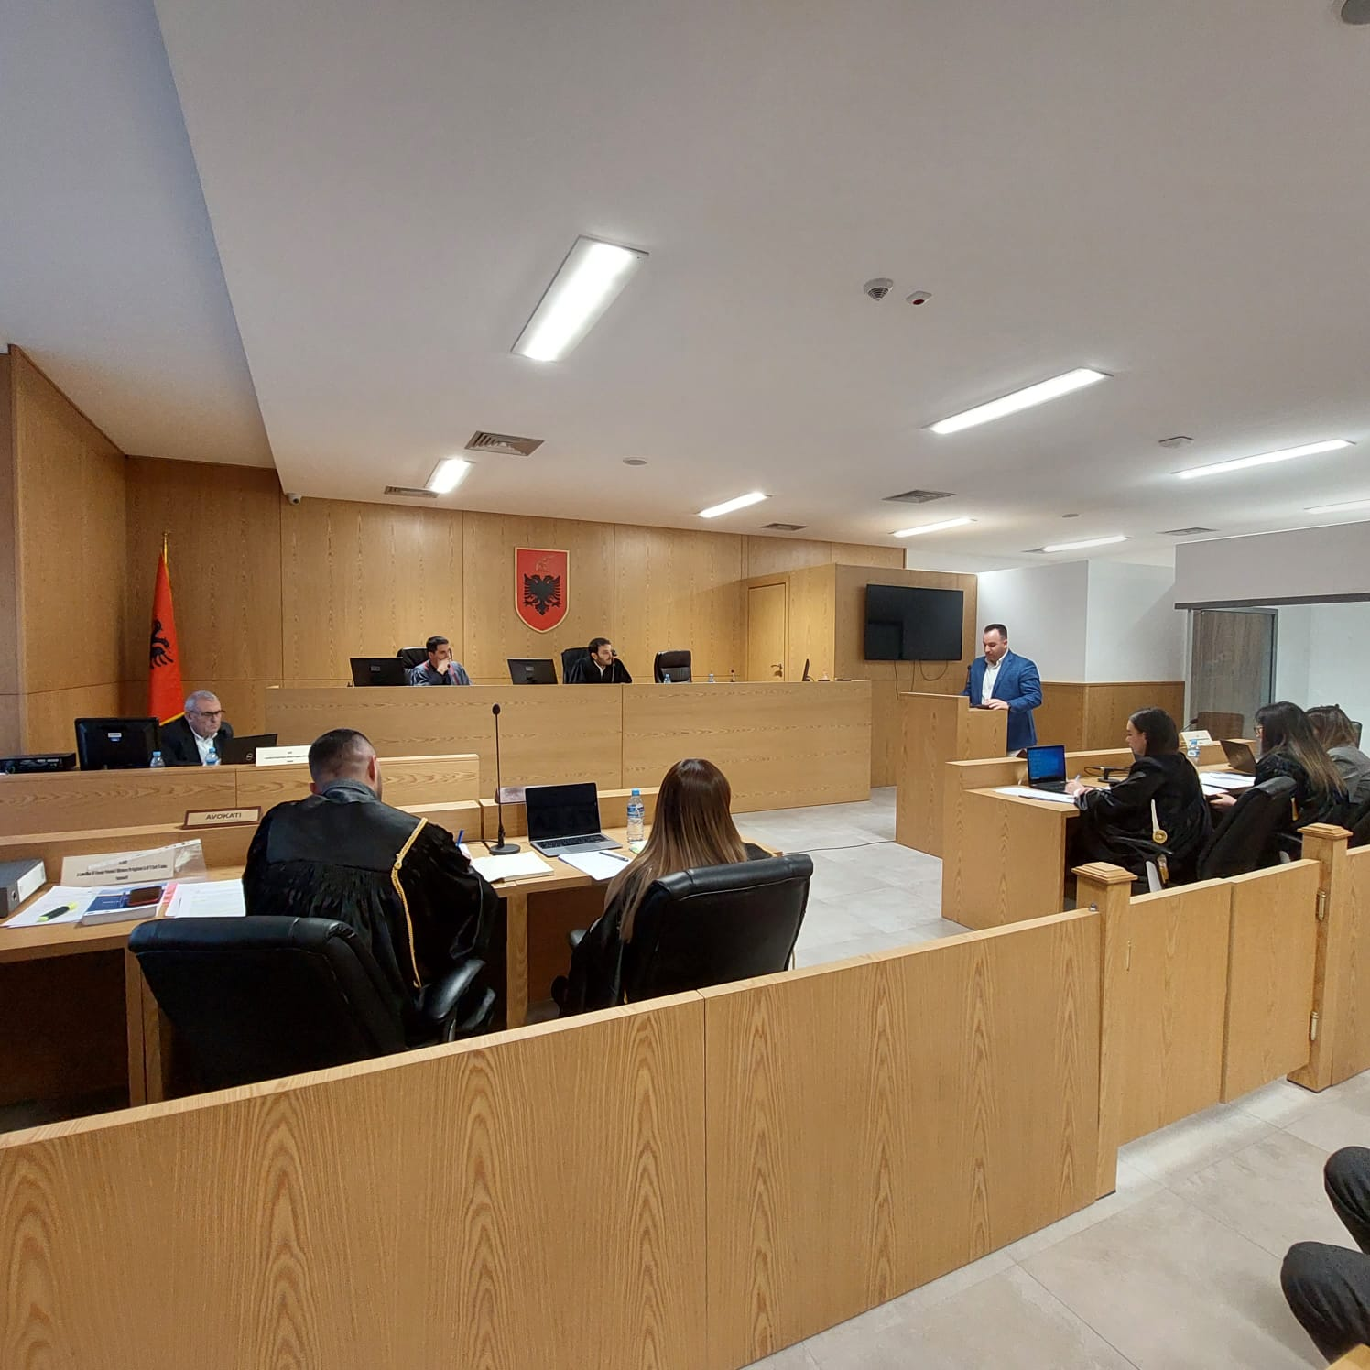
Photo of the mock trial, IInd year

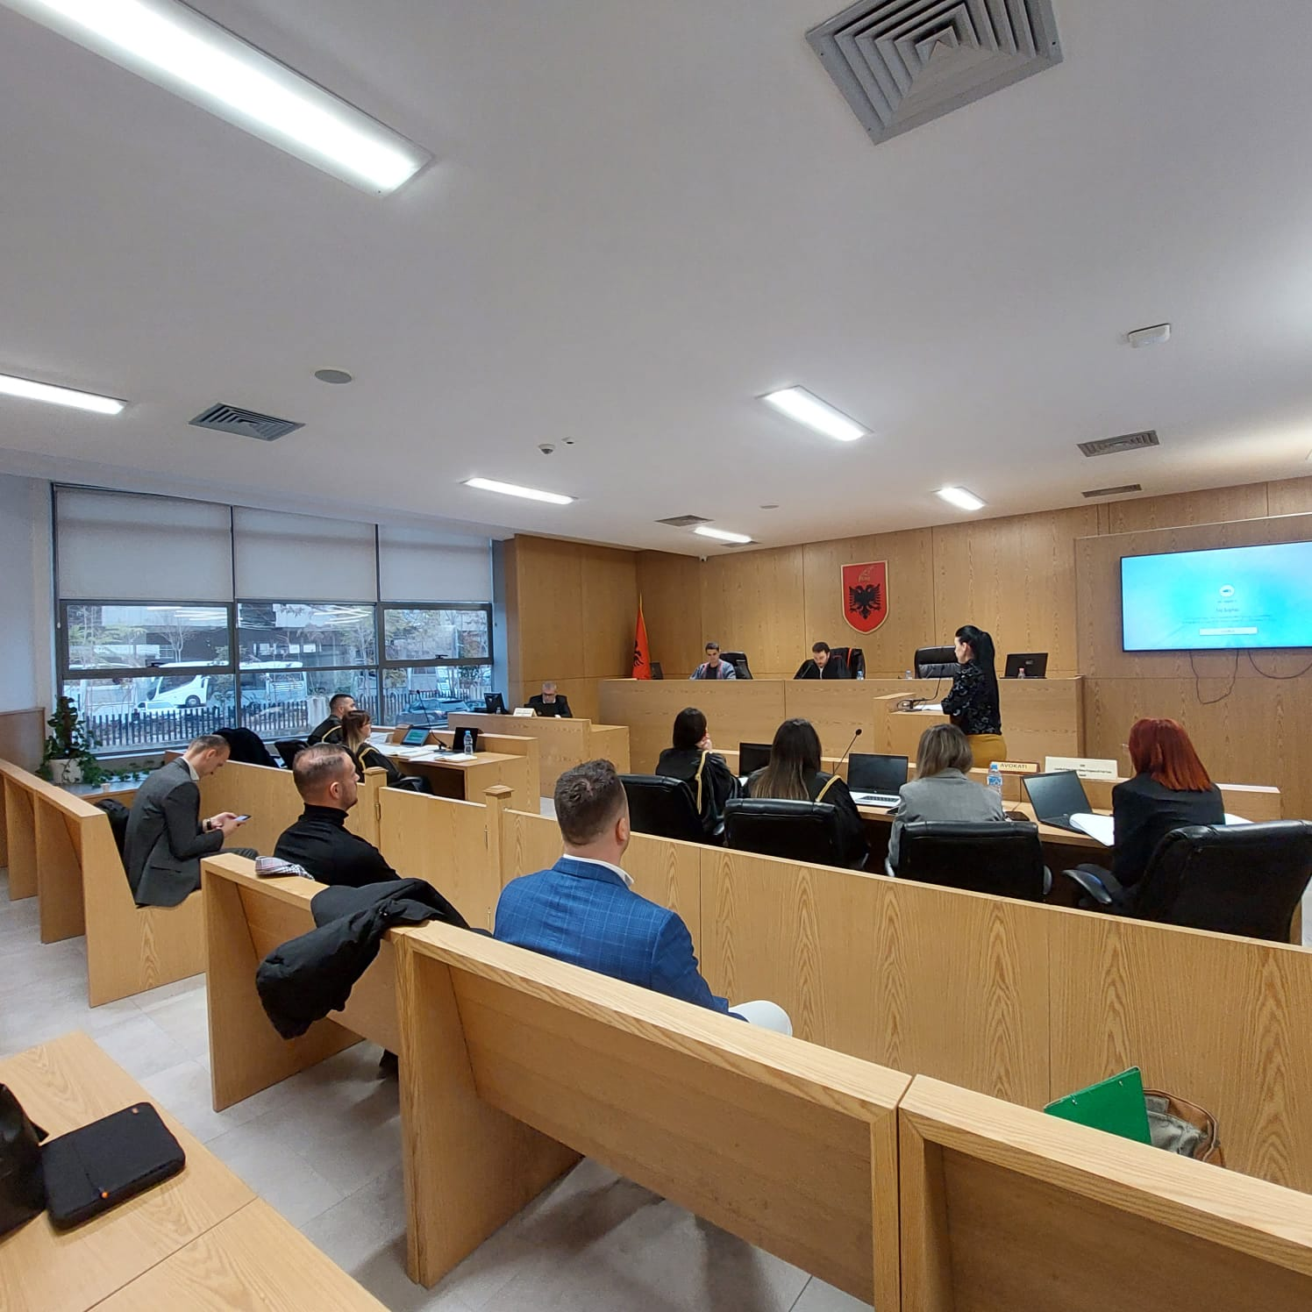

Photo of the mock trial, IInd year

