THE SCHOOL OF MAGISTRATES
OF THE REPUBLIC OF ALBANIA

IInd year
2023-2024

CIVIL MOCK TRIAL

On 23 April, 2024, candidates for magistrate of the second year, under the mentorship of lecturer Sokol Ngresi, organized the mock trial in civil law. The case chosen by the candidates was:

“Lawsuit for the reward of property and non-property damage.”
In this mock trial from candidates for magistrate were elaborated the following issues:
- Application for main interference (minor child);
- Application for call in the status of the third person of specialist doctor employee from the defendant party (that has performed morphological echo);
- Application for the addition of the object;
- Application for the procedural transition of the defendant party, because of the reorganization of the company (division in two new companies). Discussion on the subject that enjoys the procedural legitimacy in this process;
- Application for the appointment of a medical-legal expert, psychologist and assessor of damages and questions for experts;
- The submission of a new evidence after the issuing of the order for transition to the judicial session;

- Active/passive material legitimating of the litigant party;
- Elements of property damage and the process of evidencing;
- The evidencing of the elements of non-property damage;
- The value of property and non-property damage.

Mock trial, in all its phases, applied procedural rules sanctioned in the Code of Criminal Procedure, as well as respected the solemnity of the trial.

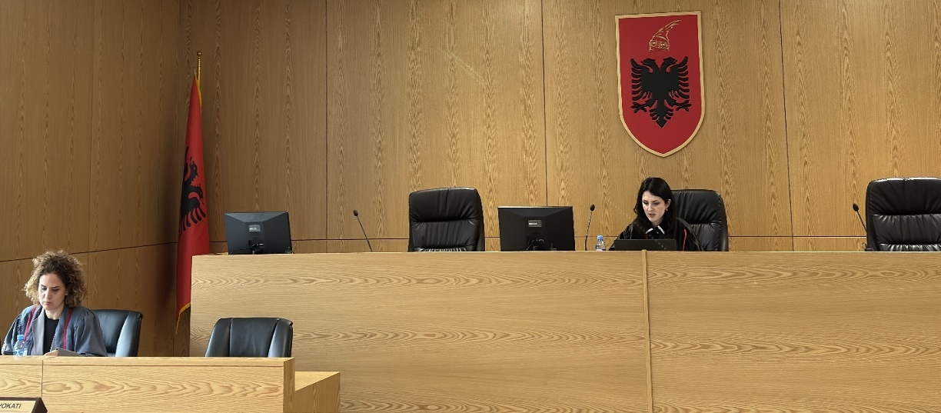

Photo of the mock trial, IInd year
