THE SCHOOL OF MAGISTRATES
OF THE REPUBLIC OF ALBANIA

IInd year
2023-2024

CIVIL MOCK TRIAL

On 26 March, 2024, candidates for magistrate of the second year, under the mentorship of lecturer Asim Vokshi, organized the mock trial in civil law. The case chosen by the candidates was related to the invalidity of the will and continues as follows:

The mock trial had to do with the claim on the invalidity of the will, because in the time of its composition, the heiress suffered from senile dementia and the notary has not verified this fact preliminarily. In parallel with the lawsuit, is presented a request for main intervention, when minor children of one of the heirs, claim the absolute invalidity of the will, claiming the violation of the legal reserve..

In this mock trial by candidates for magistrate were elaborated different issues of civil law that have to do with:
- The invalidity of the will, its nature;
- The deadline for filing a lawsuit;
- Notary obligations for the verification of the capacity of the testator to act, before the beginning of the edition of the testament;
- Legal reserve for the child;
- The actions of the judge of the preliminary hearing in cases of the presentation of an application for essential intervention.

Mock trial, in all its phases, applied the rules, as well as respected the solemnity of the trial.

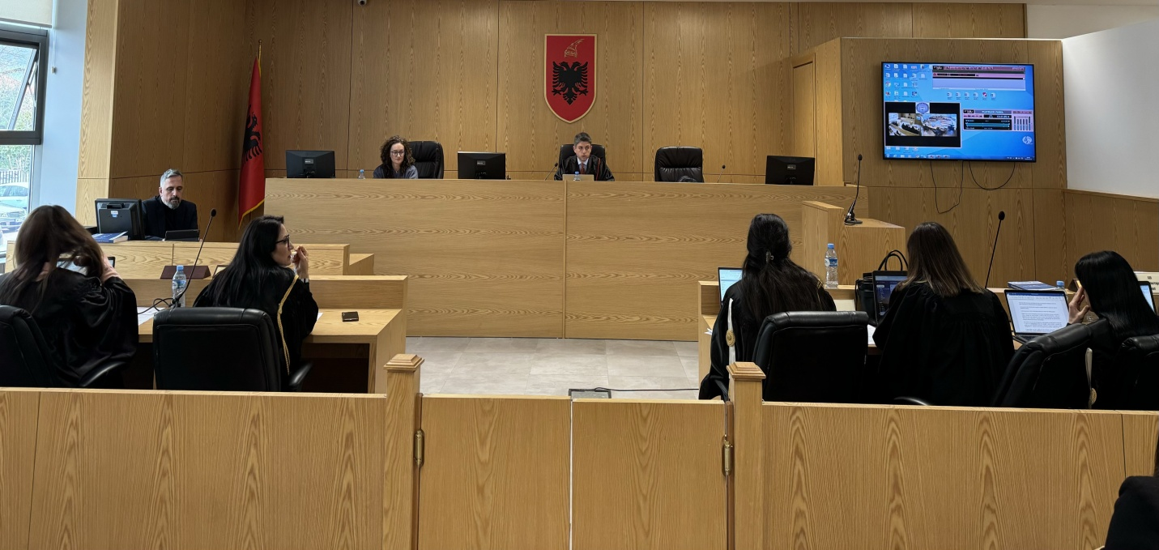

Photo of the mock trial, IInd year

