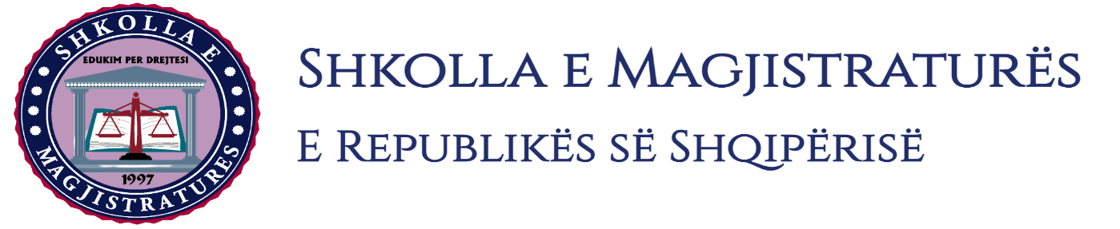

THE SCHOOL OF MAGISTRATES
OF THE REPUBLIC OF ALBANIA

IInd year
2023-2024

CIVIL MOCK TRIAL

On 29 February, 2024, candidates for magistrate of the second year, under the mentorship of Prof. Dr. Vangjel Kosta organized the civil mock trial in civil law. The case chosen by the candidates was:

“Lawsuit on the invalidity of the executive title because of the invalidity of the juridical act according to Article 609 of the Code of Criminal Procedure, as well as the suspension of the execution of the executive title bank loan contract.”

In this mock trial, candidates for magistrate elaborated different cases of civil procedural law as well as of civil material law such as:
- Conditions that should be met for the suspension of the execution of the executive title bank loan contract.
- Formation of litigation in the lawsuit on the invalidity of the title.
- Should be done the lawsuit according to the Article 609 of the Code of Criminal Procedure without the beginning of the obligatory execution?
- Should be testified the falsity of the bank loan contract through the evidence with witnesses?
- The debate on the evidencing strength of a number of evidences such as loan contracts, enterprise contracts, mortgage contract, evidence with witnesses, etc.
Mock trial, in all its phases, applied procedural rules sanctioned in the Code of Criminal Procedure, as well as respected the solemnity of the trial.

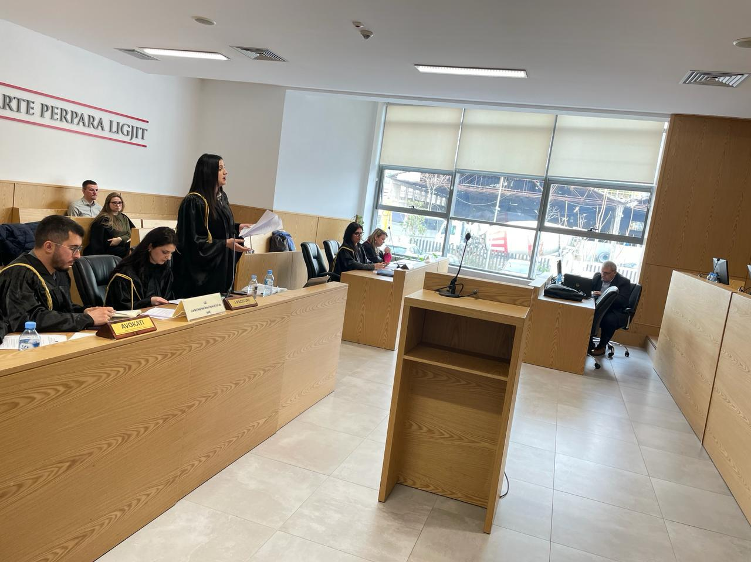
Photo of the mock trial, IInd year

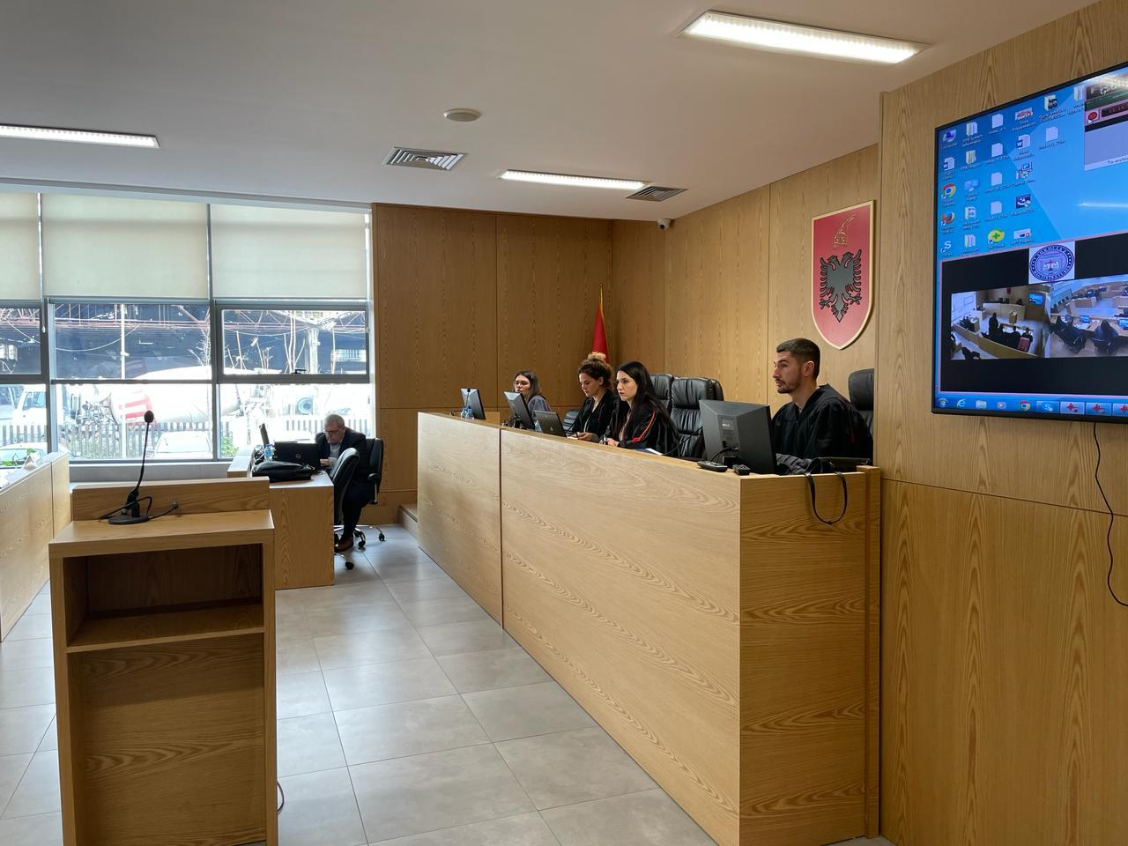
Photo of the mock trial, IInd year

