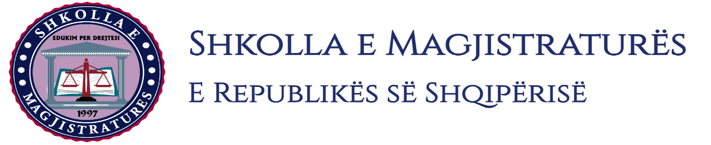
THE SCHOOL OF MAGISTRATES
OF THE REPUBLIC OF ALBANIA

IInd year
2023-2024

CIVIL MOCK TRIAL

On 29 February, 2024, candidates for magistrate of the second year, under the mentorship of Prof. Vangjel Kosta, organized the mock trial in civil law. The case chosen by the candidates was:

“The lawsuit for the invalidity of the executive title because of the invalidity of the juridical act under the Article 609 of the Code of Criminal Procedure, as well as the suspension of the execution of the executive title, bank loan contact.”

In this mock trial by candidates for magistrate were elaborated different topics, of civil procedural law and of the civil material law as follows:

- Conditions that should be met to decide the suspension of the executive title bank loan contract;
- Formation of litigation in the lawsuit for the invalidity of the title;
- Could be done the lawsuit under the Article 609 of the Code of Civil Procedure without beginning the process of the compulsory execution?
- Is proven the fictitiounsness of the bank loan contract through witness evidence?
The discussion of the evidencing force of a number of evidences such as loan contracts, enterprise contracts, mortgage contracts, witness evidence, etc.
Mock trial, in all its phases, applied procedural rules sanctioned in the Code of Civil Procedure, as well as respected the solemnity of the trial.

Photo of the mock trial, IInd year

