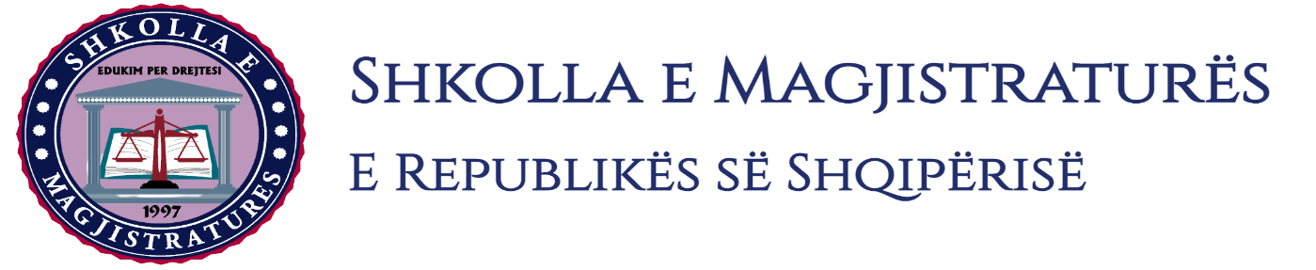

THE SCHOOL OF MAGISTRATES
OF THE REPUBLIC OF ALBANIA

IInd year
2023-2024

CIVIL MOCK TRIAL

On 29 January, 2024, candidates for magistrate of the second year, under the mentorship of Prof.Vangjel Kosta, organized the mock trial in civil law. The case chosen by the candidates was:

“The exclusion of the object from the execution and actio Pauliana.”

In the chosen case, candidates elaborated legal issues related to the instant of the gaining of ownership in a donation contract; legal action on condition; the invalidity of juridical acts; the nature of actio Pauliana; compulsory litigation and the administration of new evidences in the judicial hearing. In simulation, candidates made part of their analysis considering also the debate on the recent jurisprudence of the High Court on legal issues brought for analysis.

The mock trial, in all its phases, applies procedural rules sanctioned in the Code of Civil Procedures as well as respected the solemnity of the trial.

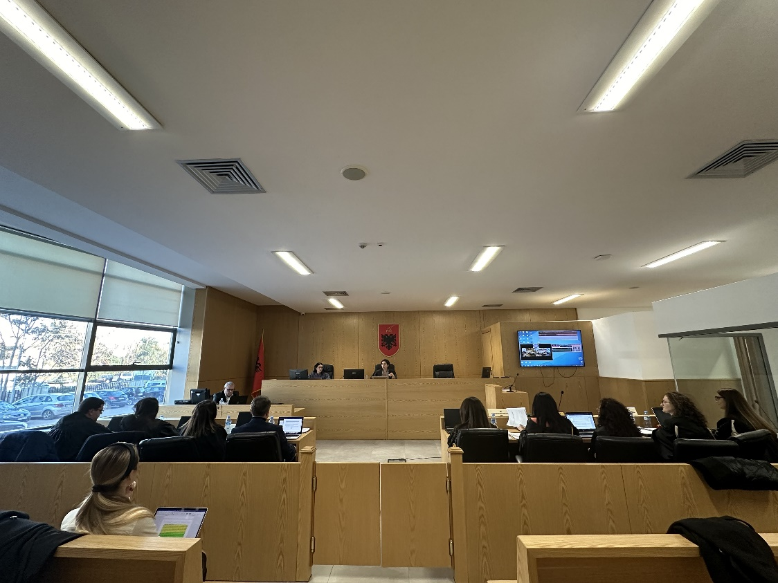
Photo of the mock trial, IInd year

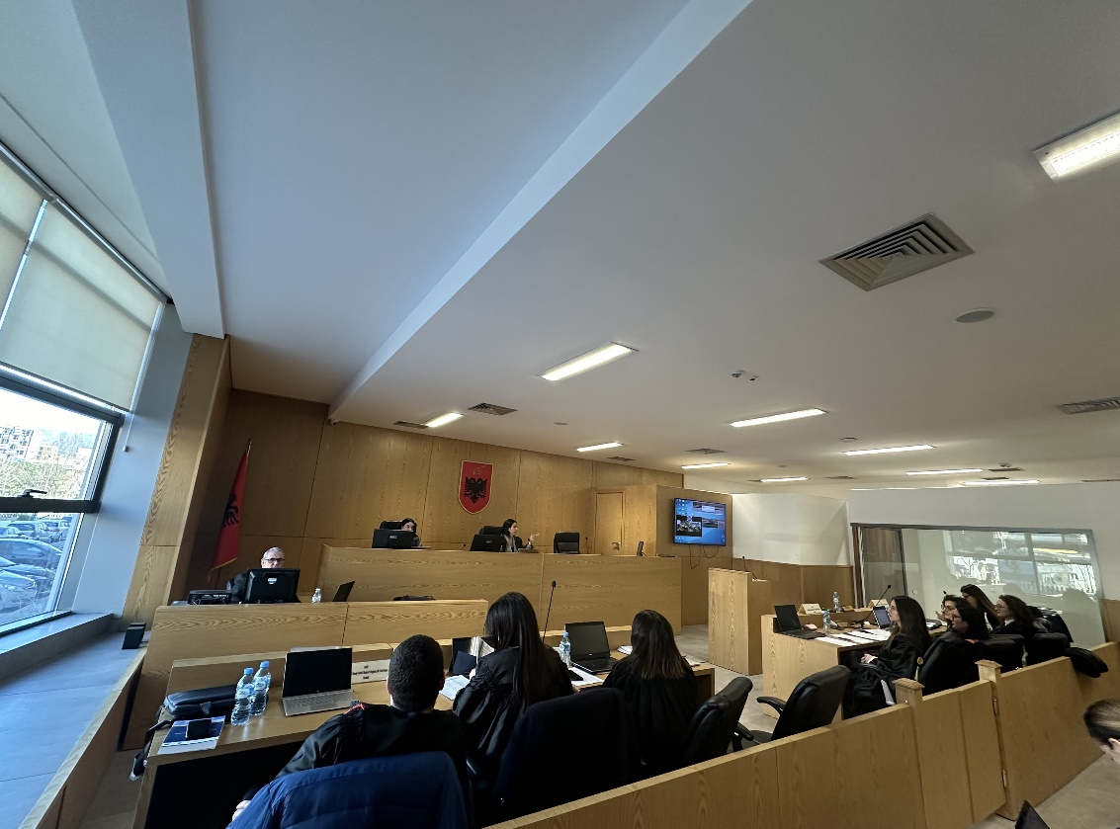

Photo of the mock trial, IInd year

