

THE SCHOOL OF MAGISTRATES
OF THE REPUBLIC OF ALBANIA

IInd year
2023-2024

CIVIL MOCK TRIAL

On 29 March, 2024, candidates for magistrate of the second year, under the mentorship of lecturer Asim Vokshi, organized the mock trial in civil law. The case chosen by the candidates was:

- “The obligation of the defendant party to pay in the favor of the plaintiff the amount of the unpaid rent that corresponds to the additional surfaces and to those constructed without permission by the defendant during the contractor relation of the rent between litigant parties, according to the value that will derive from the act of expertise.”

In the chosen case, candidates treated issues as follows:

- In the preparatory session

- The claim that the defendant does not have active procedural legitimacy, because, among others, has not been party in any of the contracts that are object of judicial examination;
- The claim that the part of obligations object of lawsuits older than three years before the filing of the lawsuit are prescribed referring to the Article 115/d of the Civil Code, consequently the lawsuit should be abrogated automatically since in the preparatory session, without judging them on the merit;

B. In the judicial session

- The claim that the legal cause of the lawsuit is partially wrong regarding the surfaces constructed by the defendant, because they have not been object of rent.
- There is the opposition that objects that are claimed to have been constructed without permission by the defendants are done according to contractor anticipations that the defendant has the right to make improvements of the rented object. Also, the connecting bridge is approved by the plaintiff party through a relevant paper, intending the connection of two objects. Referring to the Article 277 of the Civil Code, the defendant party enjoys servitude of compulsory passing in relation to it.
- The opposition that in the conditions when none of the additional surfaces is not in the ownership of the defendant party, it cannot pretend neither rent nor reward for their use and consequently, does not have the material active legitimacy regarding them.

Mock trial, in all its phases, applied procedural rules sanctioned in the Code of Civil Procedure, as well as respected the solemnity of the trial.
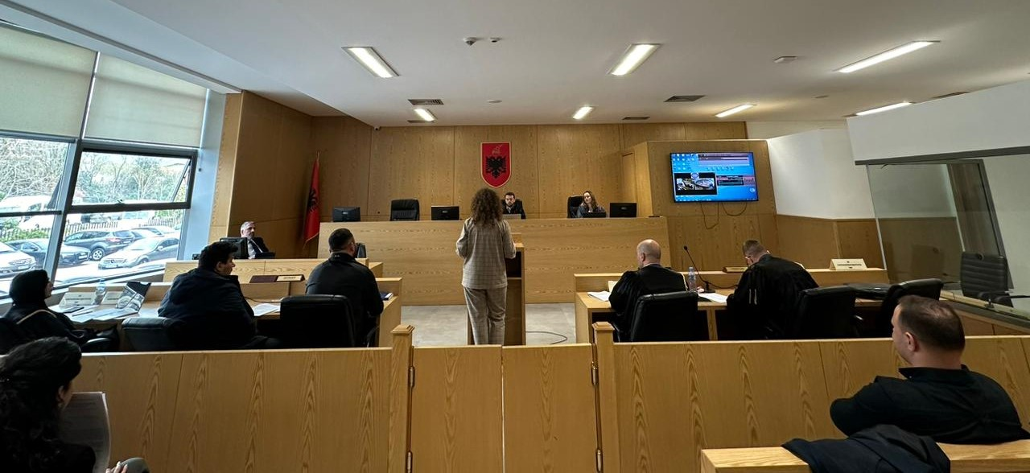
Photo of the mock trial, IInd year

