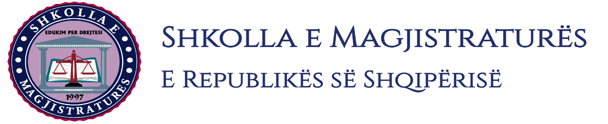

THE SCHOOL OF MAGISTRATES
OF THE REPUBLIC OF ALBANIA

IInd year
2023-2024

CIVIL MOCK TRIAL

On 30 October, 2023, candidates for magistrate of the second year, under the mentorship of Prof. Dashamir Kore, organized the civil mock trial. The case chosen by the candidates was:

“The lawsuit on damage reward done by a construction and development company, versus defendant parties, regarding a property which was under the ownership of a subject enjoying diplomatic immunity.”

In this mock trial, candidates for magistrate elaborated legal cases regarding the jurisdiction and competence of the court and of procedural aspects of the call of the third persons in the process.

Also, were evidenced the best practices of the European Court of Human Rights (ECtHR), of the Constitutional Court (CC) and of the High Court (HC), regarding the right to property, "de facto" expropriation, active and passive legitimating of parties in process and the application of the compulsory unifying jurisprudence regarding the notification of the invalidity of the acts in process.

In all the phases of this mock trial were respected the rules foreseen by the Code of Civil Procedure on the completion of the judicial process.

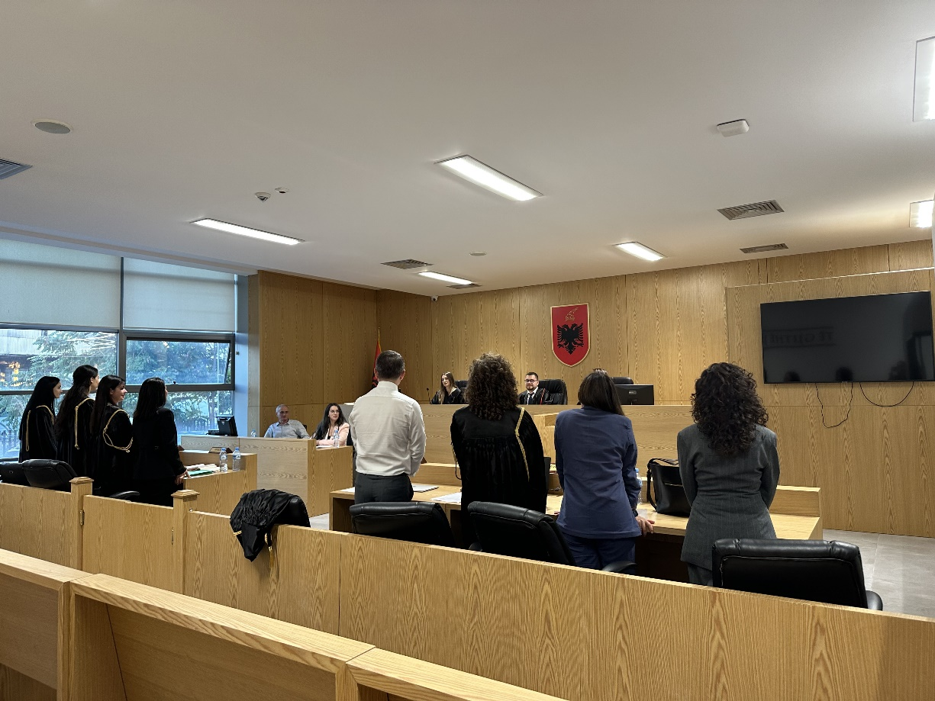
Photo of the mock trial, IInd year

