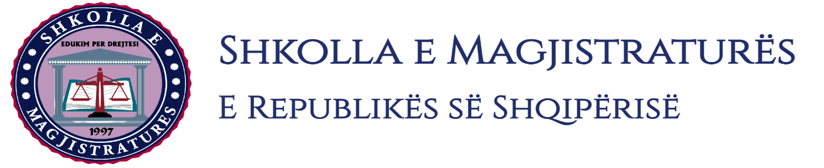

THE SCHOOL OF MAGISTRATES
OF THE REPUBLIC OF ALBANIA

IInd year
2023-2024

CRIMINAL MOCK TRIAL

On 02 February, 2024, candidates for magistrate of the second year, under the mentorship of Prof. Amarildo Laçi, organized the mock trial in criminal law. The case chosen by the candidates was:

“Violent robbery in cooperation, foreseen by the Articles 139 and 25 of the Criminal Code.”

In this mock trial, candidates for magistrate elaborated different procedural issues such as: the invalidity of the acts and the uselessness of proofs in preliminary hearing, the restitution of the acts to the prosecutor ordering him to formulate a charge and to make an application for the judgment of the case by the judge of the preliminary hearing; the application for the uselessness of a proof represented in the basic trial after being refused in the preliminary hearing.

The mock trial, in all its phases, applies procedural rules sanctioned in the Code of Criminal Procedure as well as respected the solemnity of the trial.

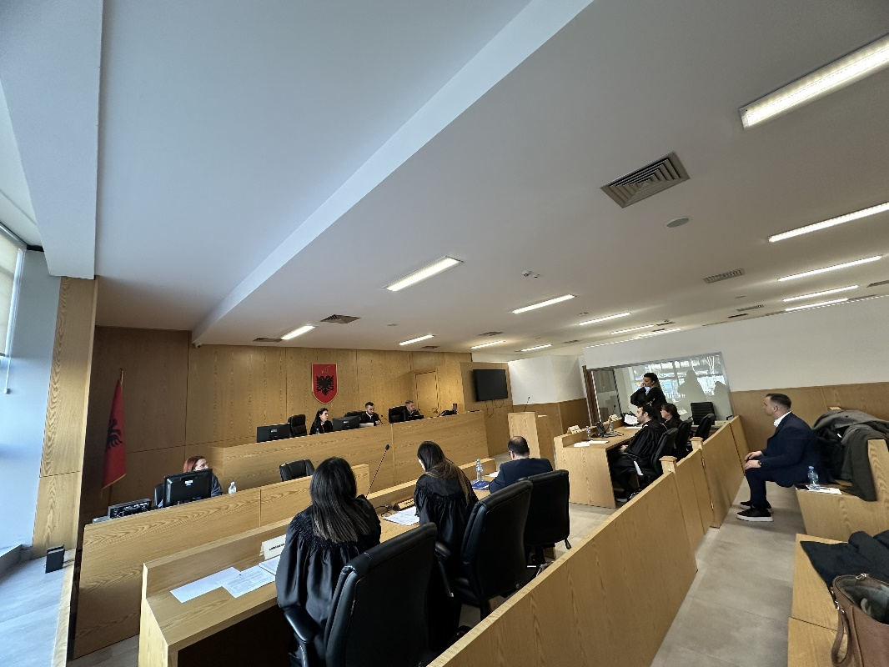
Photo of the mock trial, IInd year
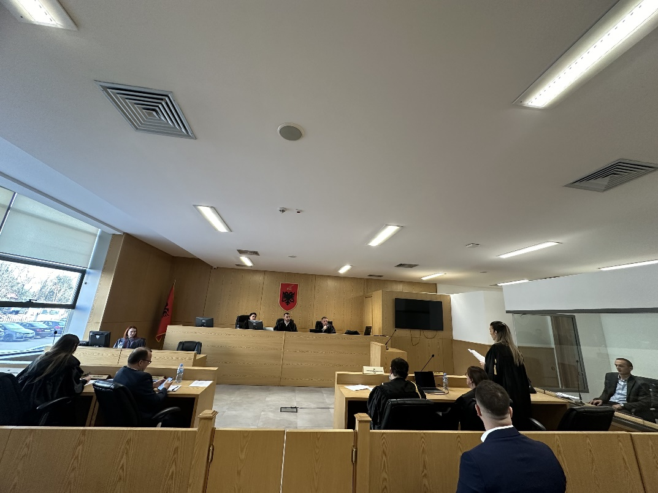

Photo of the mock trial, IInd year

