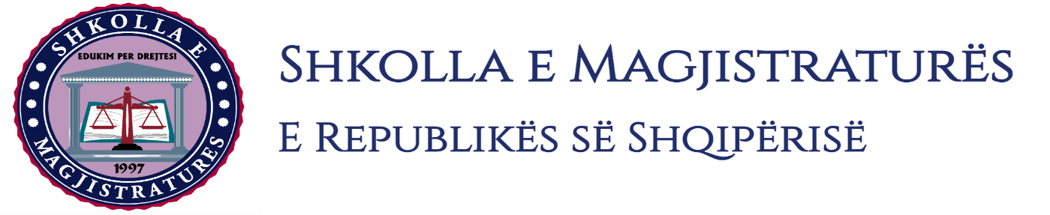

THE SCHOOL OF MAGISTRATES
OF THE REPUBLIC OF ALBANIA

IInd year
2023-2024

CRIMINAL MOCK TRIAL

On 2 May, 2024, candidates for magistrate of the second year, under the mentorship of lecturer Arben Rakipi, organized the third mock trial in criminal law.

The case chosen by the candidates was:

“Murder in other qualifying circumstances, “in cooperation, and “Illegal possession of war weapons” anticipated by Articles 79\dh 278\1 and 25 of the Criminal Code and “Murder under qualifying circumstances” remained in attempt, in cooperation, and anticipated by the Articles 79\dh, 22 and 25 of the Criminal Code.

In this mock trial, candidates for magistrate elaborated different procedural cases, such as:
- Examination of the scene crime and of the corpses;
- The interrogation of the arrested ones;
- Permission to perform simulation actions by the side of the prosecutor, in the phase of preliminary investigations;
- Hearing to the court of the case under common judgment for five defendants, as well as discussions on the invalidity and non-use of evidences in the preliminary session;
- Interrogation of defendants on the merit, interrogation as witness of persons who are informed on the criminal offense, as well as permissible readings in judicial session.

Mock trial, in all its phases, applied procedural rules sanctioned in the Code of Criminal Procedure, as well as respected the solemnity of the trial.

Photo of the mock trial, IInd year

