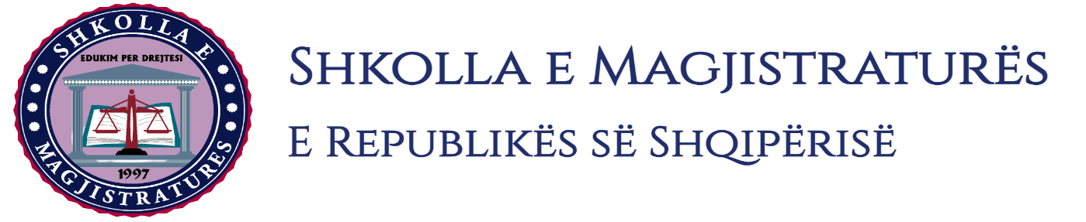

THE SCHOOL OF MAGISTRATES
OF THE REPUBLIC OF ALBANIA

IInd year
2023-2024

CRIMINAL MOCK TRIAL

On 03 November, 2023, candidates for magistrate of the second year, under the mentorship of Prof. Henrik Ligori, organized the criminal mock trial. The case chosen by the candidates was:
“The criminal offense of the intentionally grievous bodily harm, illegal possession of firearms and the non-denunciation of the crime. ”

In this mock trial, candidates for magistrate elaborated different procedural issues of the interrogation of the person arrested during the phase of preliminary investigations, of the invalidity of the acts and of the non-use of evidences in the preliminary hearing, of the civil lawsuit in the criminal process and of the primary judgment.
The mock trial, in all its phases applied the procedural rules sanctioned by the Code of Criminal Procedure as well as respected the solemnity of the trial.

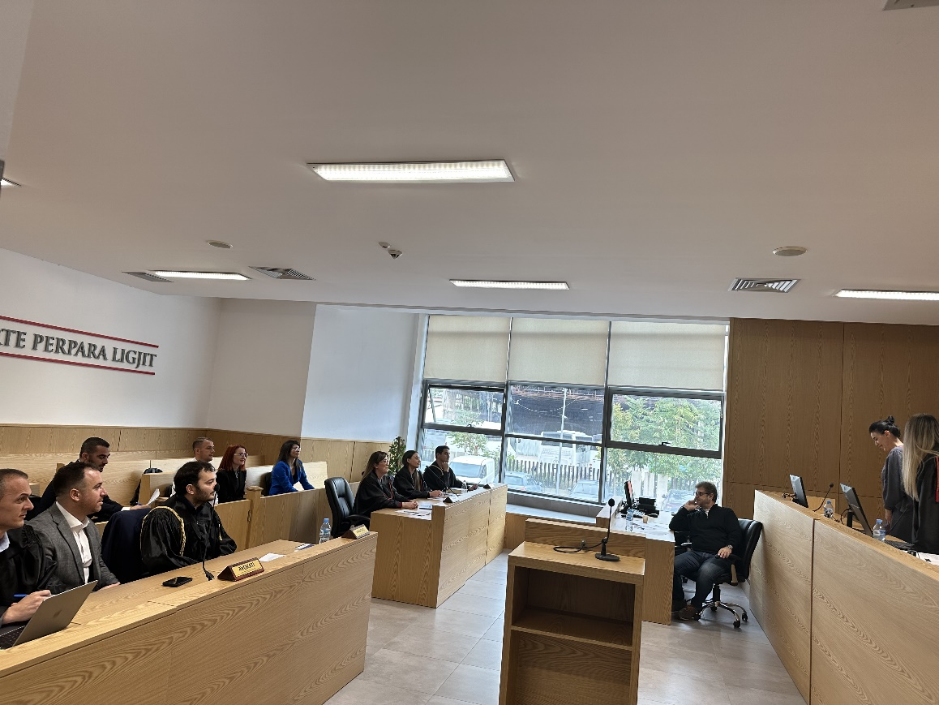
Photo of the mock trial, IInd year

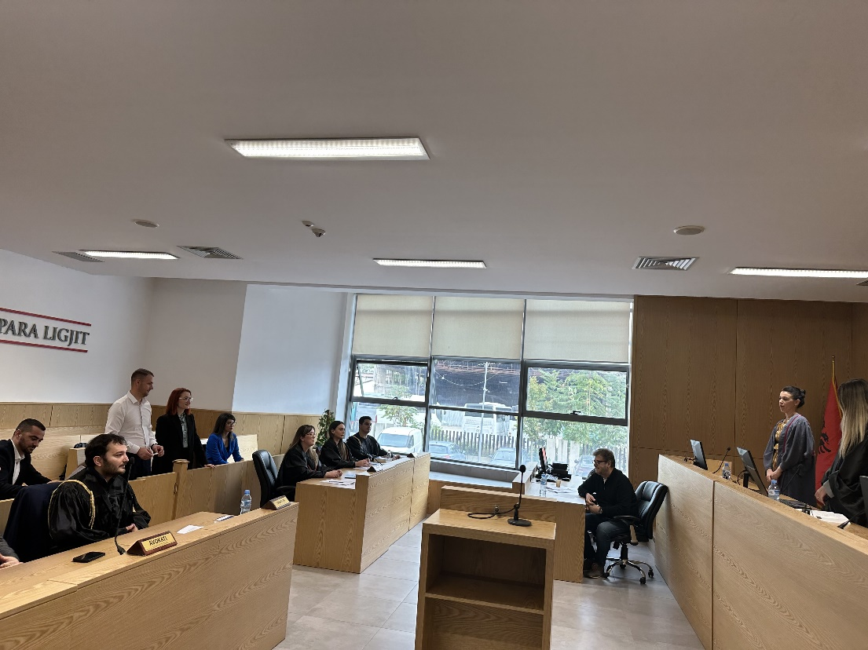
Photo of the mock trial, IInd year

