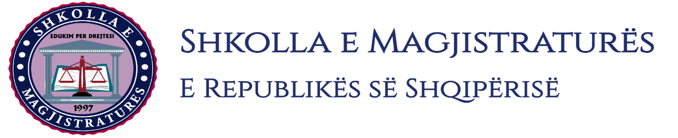

THE SCHOOL OF MAGISTRATES
OF THE REPUBLIC OF ALBANIA

IInd year
2023-2024

CRIMINAL MOCK TRIAL

On 4 March, 2024, candidates for magistrate of the second year, under the mentorship of judge Gerd Hoxha, organized the mock trial in criminal law. The case chosen by the candidates was:

- “Production and sale of narcotic drugs”, done in cooperation, foreseen by the Article 283, paragraph 2 of the Criminal Code.

- “Entry or possession of prohibited items in the institution of the execution of prison sentences decisions”, foreseen by the Article 324/a, paragraph 2 of the Criminal Code.

This trial was done in three phases:
- The hearing for the validation of arrest in flagrante delicto and the giving of safety measure where were discussed cases of arrest in flagrante delicto, conditions that should be met for the determination of safety measures, application for the giving of safety measure “arrest in prison” for the person under investigation who is under the safety measure “arrest in prison” because of another criminal proceeding (the overlapping of safety measures), the change of the declaration of the person under investigation during the hearing.
- Preliminary hearing where were elaborated procedural aspects as an application for the abbreviated judgment only for one of the defendants in cases when are accused for the commitment of criminal offenses in cooperation, application for confrontation between two defendants, application for the interrogation of the defendant, application for completion of investigations.
- The trial session on the merits where were treated procedural aspects such as procedural aspects such as interrogation of witnesses, partial opposition of the witness, interrogation of the defendant in a related proceeding, etc.
During the mock trial, the group discussed on a number of elements of criminal procedural law and criminal material law, where in all phases of the mock trial were respected the rules foreseen by the Code of Criminal Procedure regarding the progress of the trial process. All members of the group demonstrated respect for the solemnity of the trial. During the mock trial, the group discussed for a number of elements of criminal procedural law and criminal material law, where in all the phases of the mock trial were respected the rules foreseen by the Code of Criminal Procedure regarding the completion of the judicial process. All members of the group respected the solemnity of the trial.

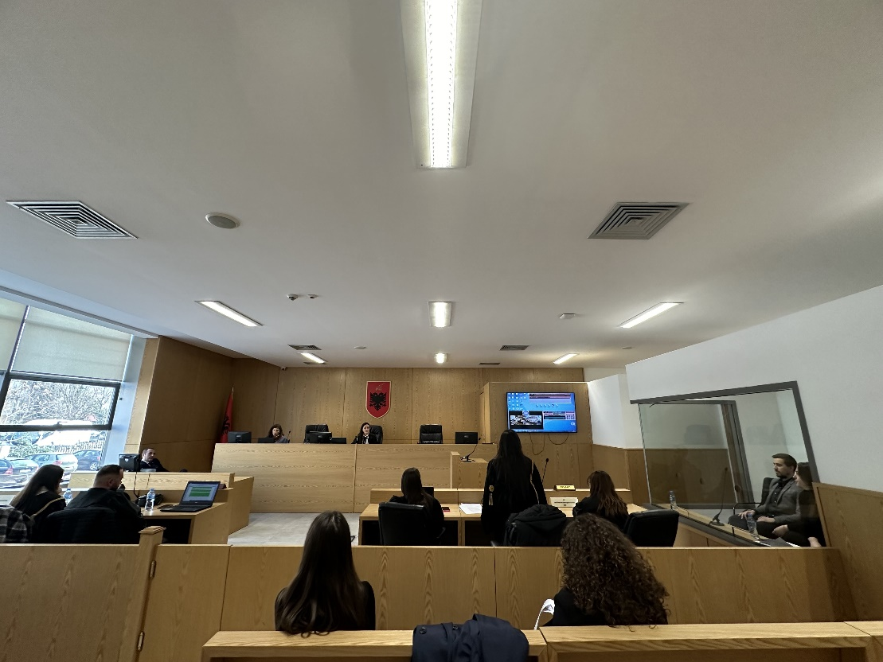

Photo of the mock trial, IInd year

