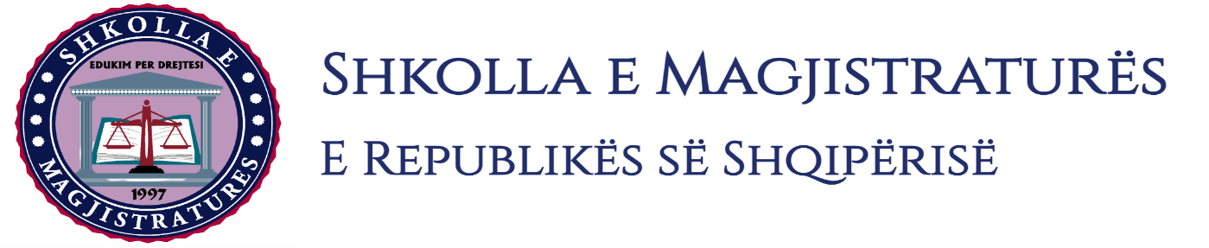

THE SCHOOL OF MAGISTRATES
OF THE REPUBLIC OF ALBANIA

IInd year
2023-2024

CRIMINAL MOCK TRIAL

On 7 March, 2024, candidates for magistrate of the second year, under the mentorship of lecturer Henrik Ligori, organized the second mock trial in criminal law. The case chosen by the candidates was:

“Passive corruption of persons who exercise public functions, in cooperation, anticipated by the Articles 259 and 25 of the Criminal Code and “Active corruption of persons who exercise public functions as well “Counterfeiting of coins”, anticipated by the Articles 244 and 183 of the Criminal Code.”

In this mock trial, candidates for magistrate elaborated different procedural cases of the interrogation of persons arrested during the phase of preliminary investigations, the imposing of the measure of personal safety in the session for the validation of arrest in flagrante delicto and the imposing of the measure of personal safety. The sending of the case to the court for the ordinary trial for the three defendants, as well as discussions on the invalidity and non-usability of evidences in preliminary session. The interrogation of the defendants on the merit, are interrogated as witnesses of persons who have information for the criminal offense, as well as the presentation of the evidence with video to verify the charge in the trial.
The mock trial, in all its phases, applied procedural rules sanctioned in the Code of Criminal Procedure as well as respected the solemnity of the trial.

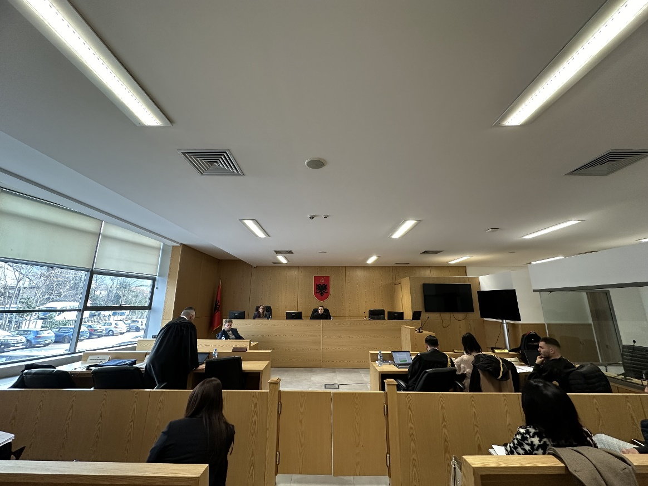
Photo of the mock trial, IInd year

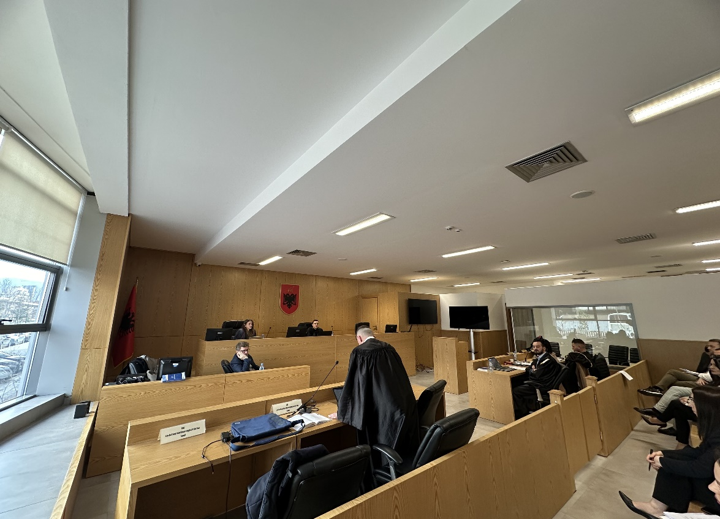
Photo of the mock trial, IInd year

