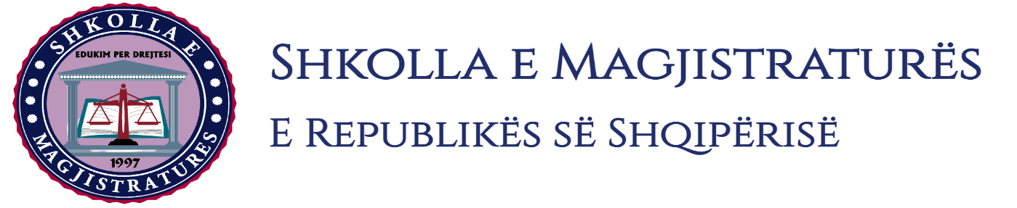

THE SCHOOL OF MAGISTRATES
OF THE REPUBLIC OF ALBANIA

IInd year
2023-2024

CRIMINAL MOCK TRIAL

On 11 December, 2023, candidates for magistrate of the second year, under the mentorship of Prof. Amarildo Laçi, organized the criminal mock trial. The case chosen by the candidates elaborated two charges presented by the prosecution for the criminal offenses of:

"Exercise of illegal influence" and “Passive corruption", for an action done in the cadastre offices.

In this simulating trial, candidates for magistrate elaborated legal issues that have to do with the judicial qualification of the criminal fact (the difference between fraud and the exercise of illegal influence), uselessness of evidences, the jurisdiction of the court of the preliminary hearing to decide the suspension of the case and the use of the results of the representation for recognition. In this simulating trial, were evidenced the best practices of the European Court of Human Rights (ECtHR) and of the High Court (HC), regarding the elaborated procedural aspects and the guarantees of the defendants in the process.

The mock trial, in all its phases, applied the procedural rules sanctioned in the Code of Criminal Procedure as well as respected the solemnity of the trial.
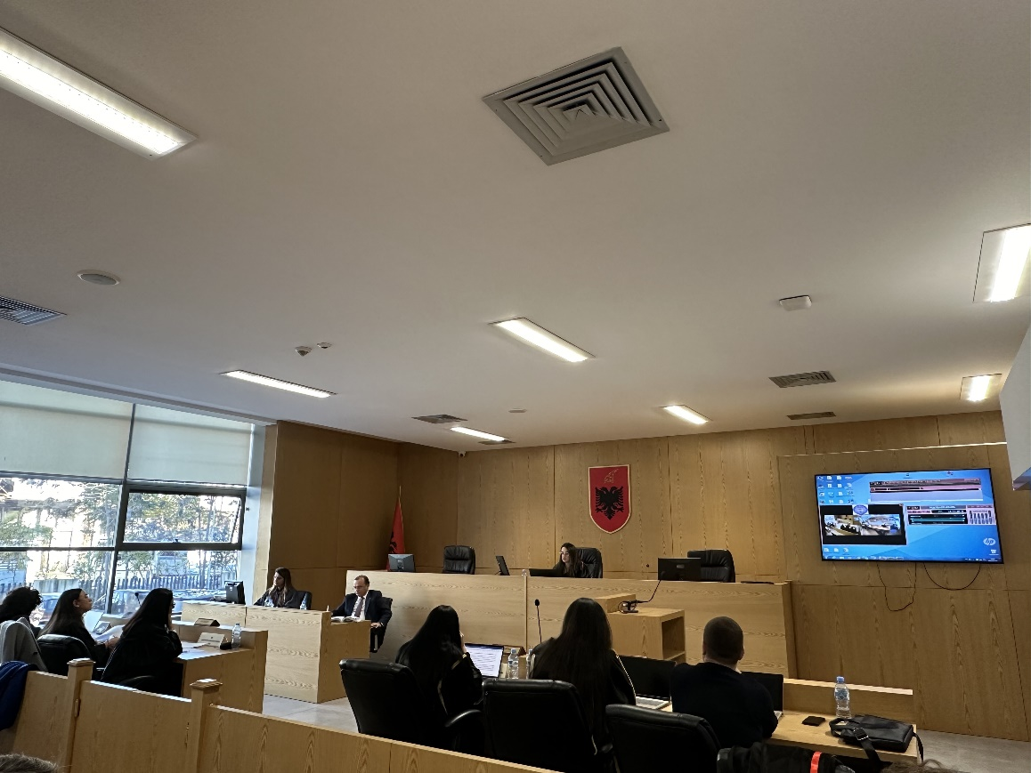
Photo of the mock trial, IInd year

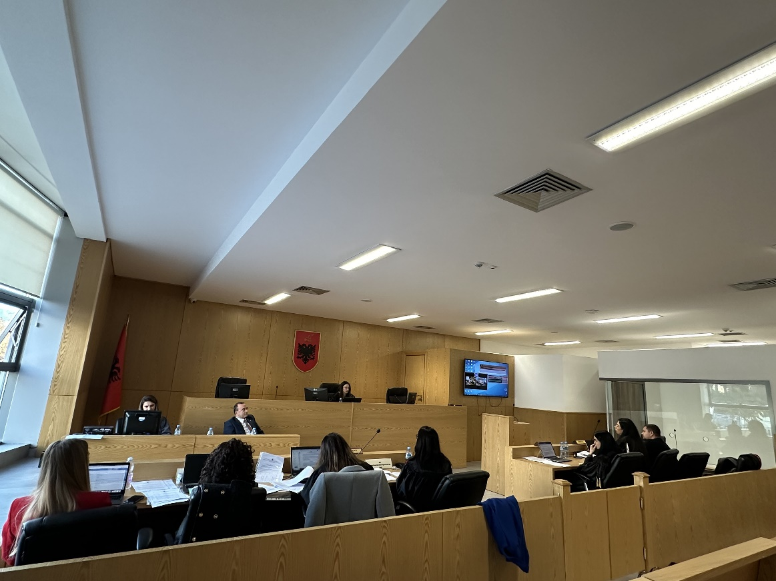
Photo of the mock trial, IInd year

