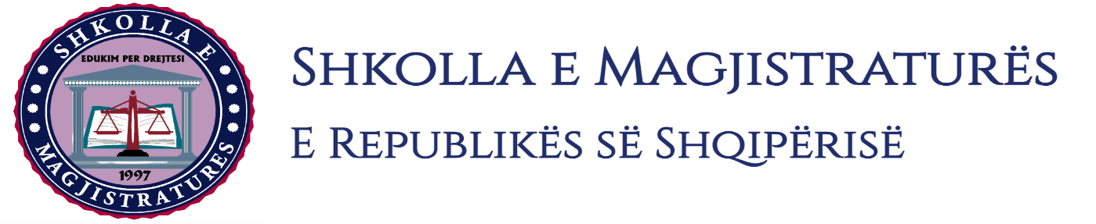

THE SCHOOL OF MAGISTRATES
OF THE REPUBLIC OF ALBANIA

IInd year
2023-2024

CRIMINAL MOCK TRIAL

On 15 December, 2023, candidates for magistrate of the second year, under the mentorship of prosecutor Madrid Kullolli, organized the first mock trial in criminal law. The case chosen by the candidates was:

“The causing of suicide” and “Coercion by means of threat or violence to give away property “committed in cooperation, foreseen respectively by the Articles 99, 109/b, point 1 and Article 25 of the Criminal Code.

In this mock trial, candidates for magistrate elaborated different procedural issues of interrogation of the arrested person in the phase of preliminary investigations, of the invalidity of acts and of the useless of proofs in the preliminary hearing, of the interrogation as witnesses of the defendant and of the victim in the trial on merits.
The mock trial, in all its phases, applies procedural rules sanctioned in the Code of Criminal Procedure as well as respected the solemnity of the trial.

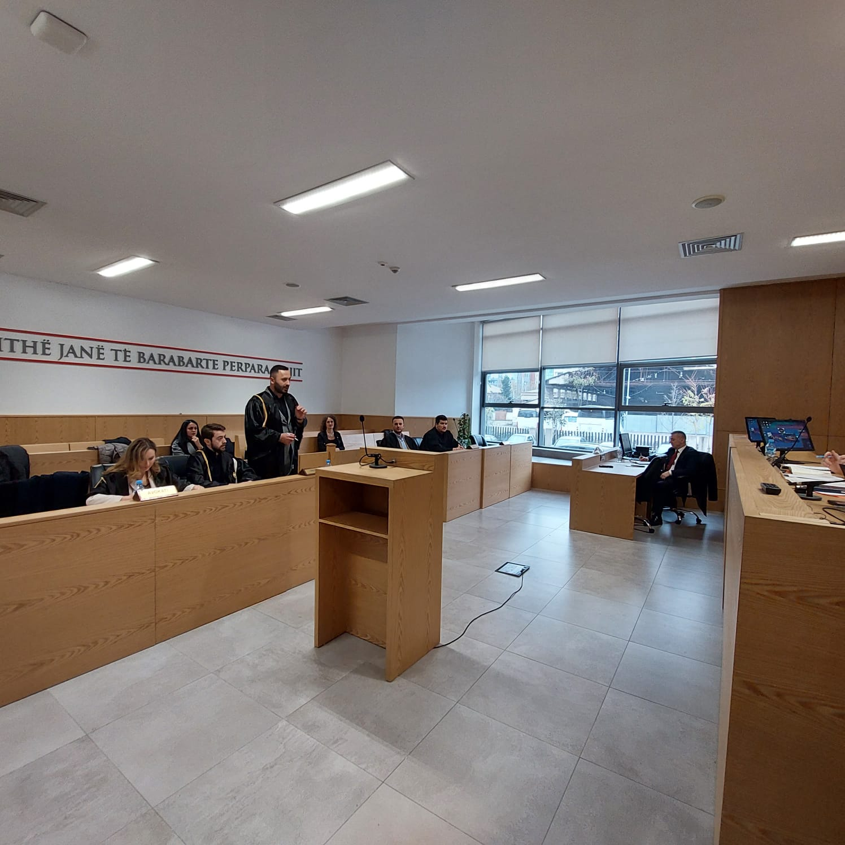
Photo of the mock trial, IInd year

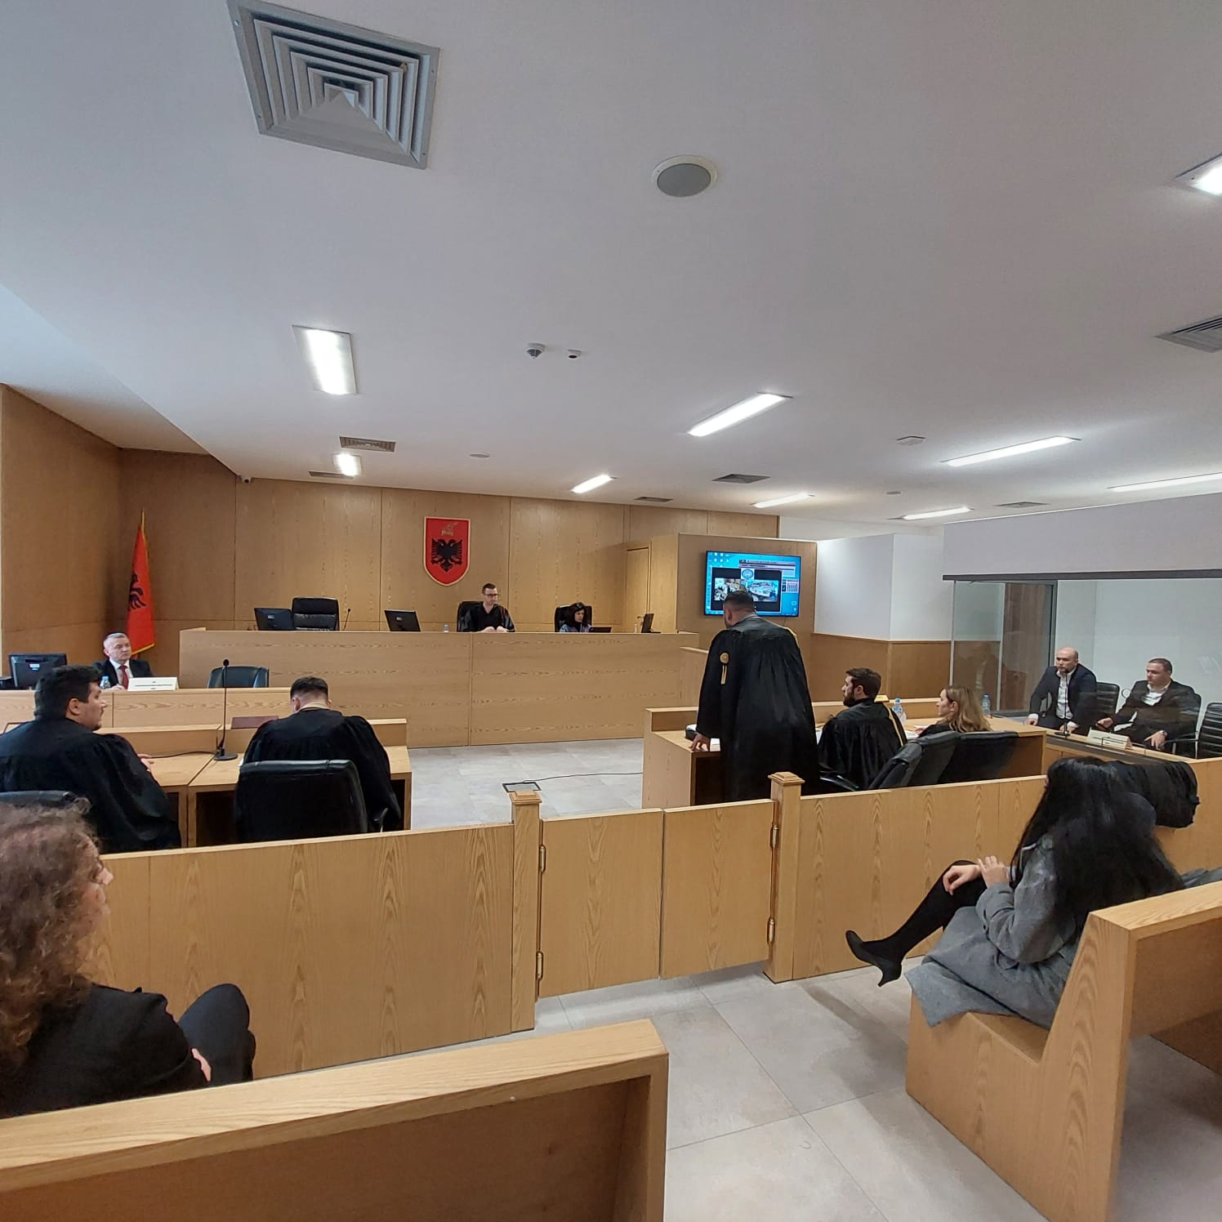
Photo of the mock trial, IInd year

