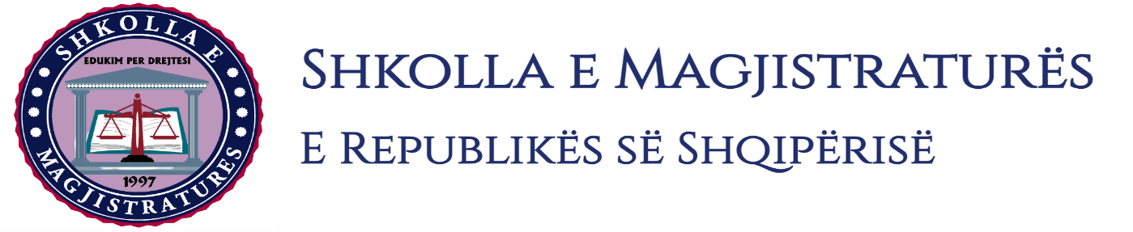

THE SCHOOL OF MAGISTRATES
OF THE REPUBLIC OF ALBANIA

IInd year
2023-2024

CRIMINAL MOCK TRIAL

On 18 December, 2023, candidates for magistrate of the second year, under the mentorship of Prof. Henrik Ligori, organized the first mock trial in criminal law. The case chosen by the candidates was:

“Criminal offenses of premeditated murder committed in cooperation, and production and possession out of permission of sporting and hunting guns.”

In this mock trial, candidates for magistrate elaborated different procedural issues such as: the interrogation of the arrested person during the phase of preliminary investigations, of the invalidity of acts and the non use of evidences in the preliminary hearing and interrogation of witnesses, partial opposition of evidence, the obtaining of atypical evidence, permissible readings in the trial on merits.

During the mock trial, the group discussed on a number of elements of criminal procedural law and of criminal material law, where in all the phases of this mock trial were respected rules foreseen by the Code of Criminal Procedure regarding the progress of the judicial process. All members of the group respected the solemnity of the trial.

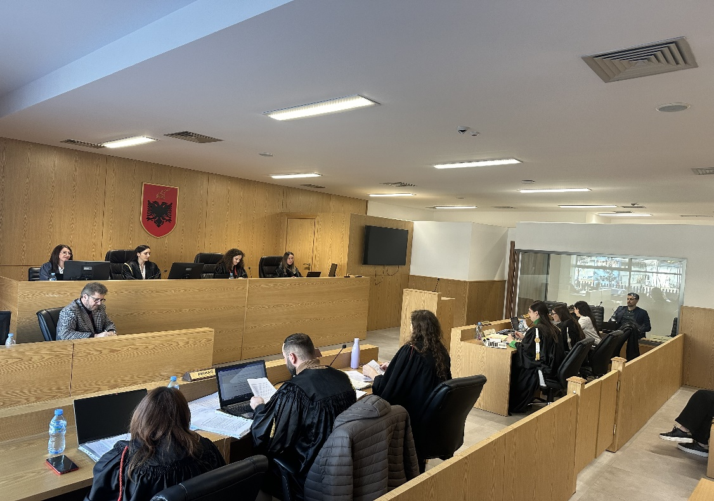
Photo of the mock trial, IInd year

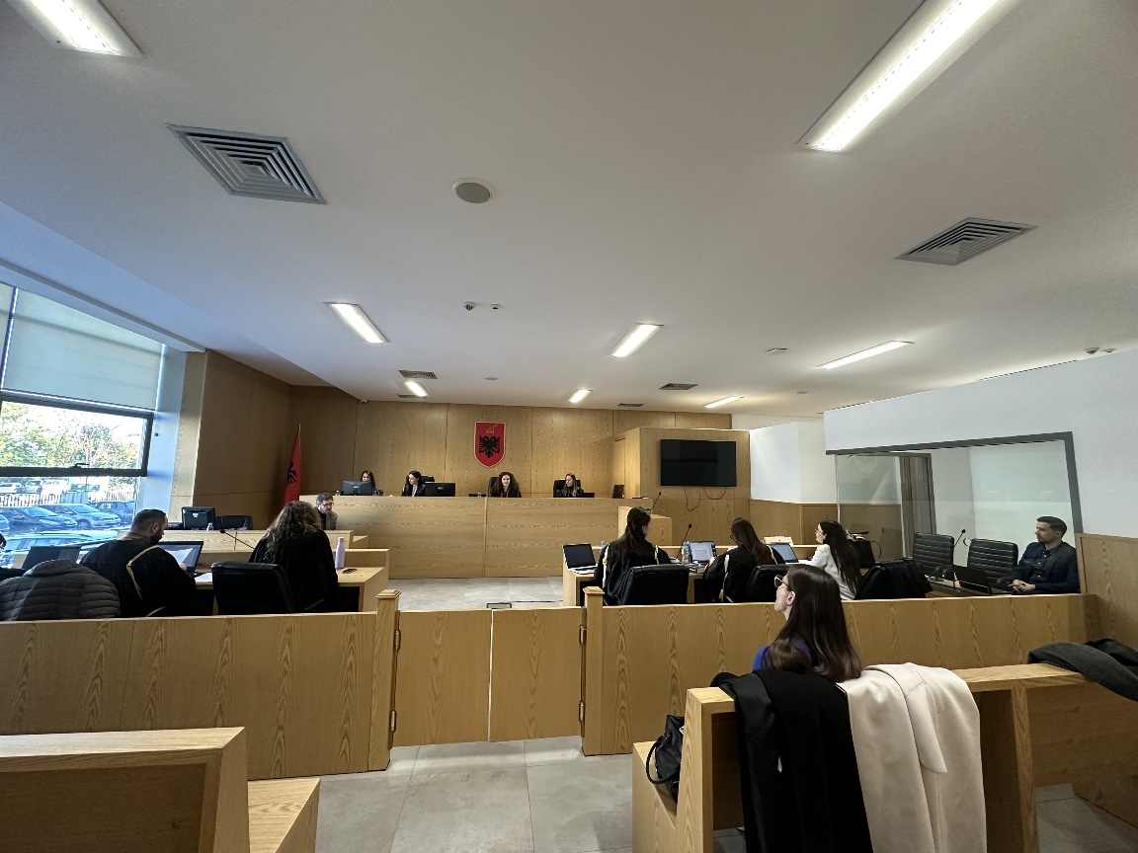
Photo of the mock trial, IInd year

