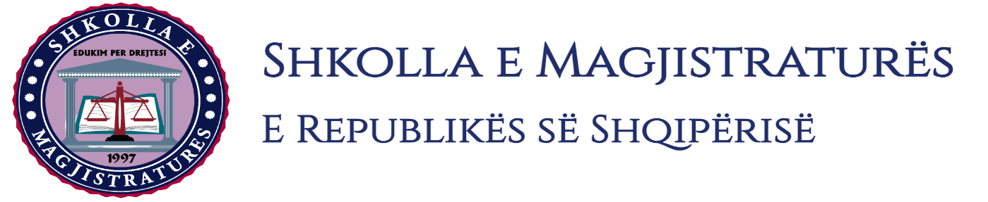
THE SCHOOL OF MAGISTRATES
OF THE REPUBLIC OF ALBANIA

IInd year
2023-2024

CRIMINAL MOCK TRIAL

On 22 December, 2023, candidates for magistrate of the second year, under the mentorship of Prof. Amarildo Laçi, organized the mock trial in criminal law. The case chosen by the candidates was:

“Murder in other qualifying circumstances,” committed in cooperation, and “Illegal possession and production of weapons, explosive weapons and ammunition,” anticipated by the Articles 79/dh, 25 and 278/1 of the Criminal Code.
“Crime non - denunciation” and “Actions that hinder the clearing of the truth” committed in cooperation, anticipated by the Articles 300\2 and 30 1 and 25 of the Criminal Code.

In this mock trial, candidates for magistrate elaborated different procedural issues of the interrogation of the arrested person during the phase of preliminary investigations, suspension of the trial for two defendants that are not found in the preliminary hearing, the accepting of the abbreviated trial by the court for two other defendants. The interrogation as witness of the defendants and of the heir of the victim, interrogation as witness of persons who have information on the criminal offense in trial, permissible readings on the merit.
The mock trial, in all its phases, applies procedural rules sanctioned in the Code of Criminal Procedure as well as respected the solemnity of the trial.

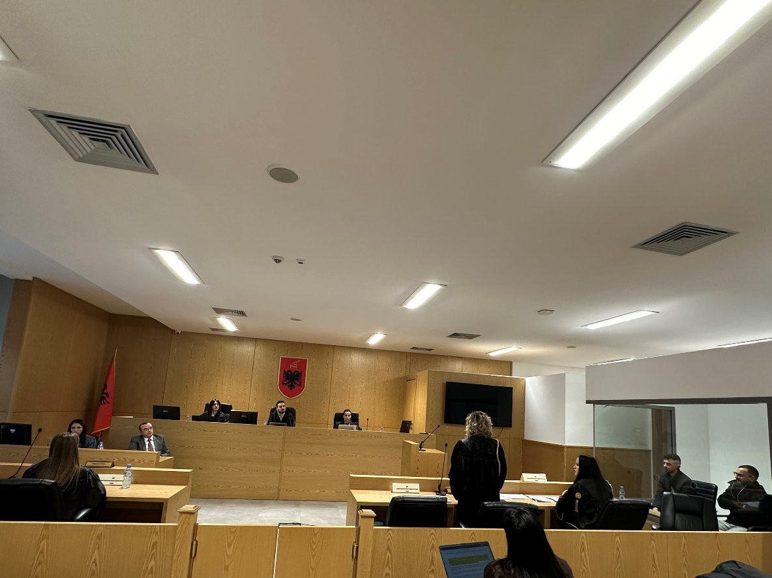
Photo of the mock trial, IInd year

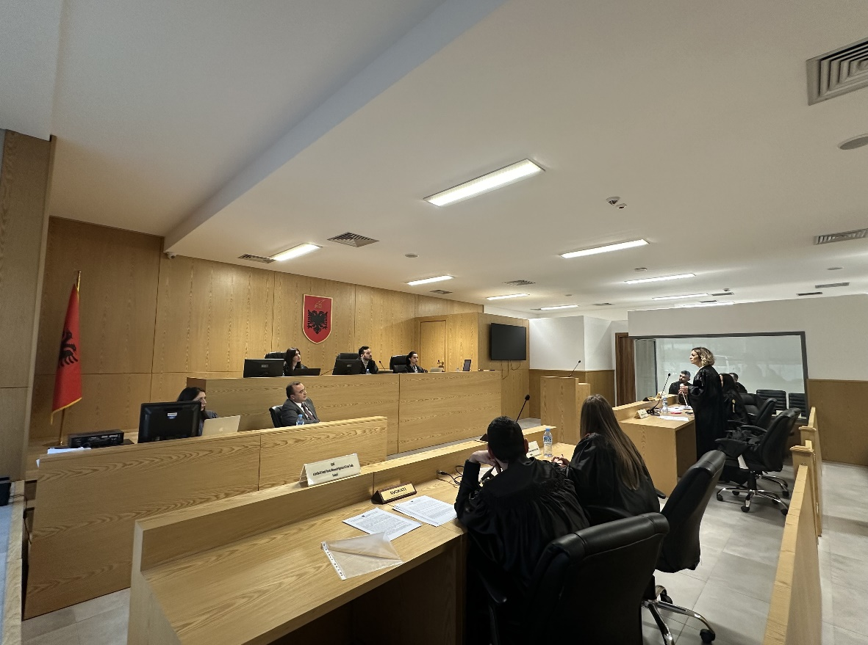
Photo of the mock trial, IInd year

