THE SCHOOL OF MAGISTRATES
OF THE REPUBLIC OF ALBANIA

IInd year
2023-2024

CRIMINAL MOCK TRIAL

On 23 April, 2024, candidates for magistrate of the second year, under the mentorship of prosecutor Arqilea Koça, organized the third mock trial in criminal law.

“The chosen case elaborated the accuse done for "premeditated murder", where the evidencing elements were coming from clues.”

In this mock trial, candidates for magistrate elaborated legal issues that have to do with the existence or not of the motive as a composing element of the criminal offense:

- The nature of clues and are they sufficient in the direction of the evidencing of the criminal offense;

- Invalidity and non-usability;

- Circumstances of knowing and analyzing the principle of “beyond a reasonable doubt."

In this mock trial, were seen the best practices of the European Court of Human Rights (ECtHR) and of the High Court (HC), regarding the elaborated procedural aspects.

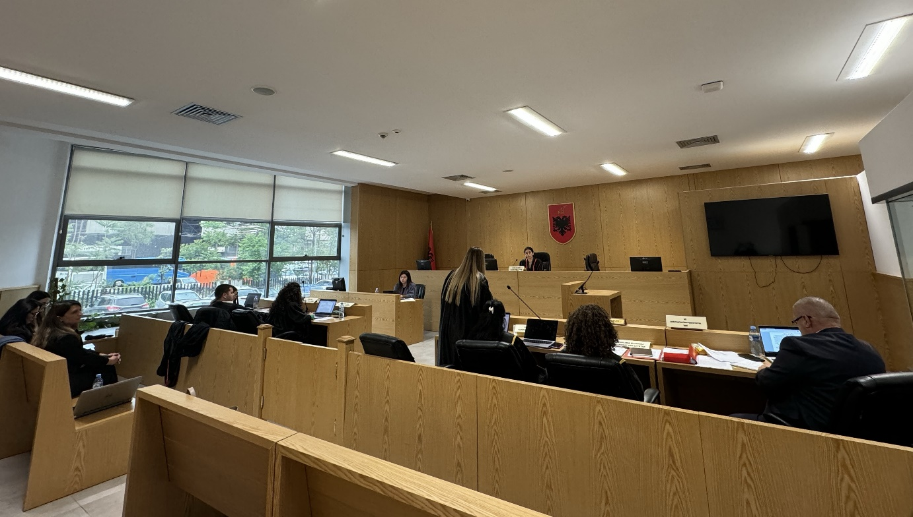

Photo of the mock trial, IInd year

