
THE SCHOOL OF MAGISTRATES
OF THE REPUBLIC OF ALBANIA

IInd year
2023-2024

CRIMINAL MOCK TRIAL

On 26 candidates for magistrate of the second year, under the mentorship of lecturer Amarildo Laçi, organized the mock trial in criminal law. The case chosen by the candidates, related to the criminal offenses as follows:

“Passive corruption of high state officials or of local elected officials” foreseen by the Article 260 of the Criminal Code, the criminal offense of the “Cleaning of the products of the criminal offense or of the criminal activity” anticipated by the Article 287 of the Criminal Code and “Active corruption of high state officials or of local elected officials” anticipated by the Article 245 of Criminal Code.”

In this mock trial by candidates for magistrate were elaborated different cases of criminal procedural law and of the material law such as: “Declaration of the invalidity of the application for the submission of the case to the court referring to Articles 129, 323, 327 and 331 of the Code of Criminal Procedure; declaration as illegal of the control of the residence of the defendant with the initiative of the officers of the National Bureau of Investigation and the non-use of the results of sequestration;
- the declaring as not usable of the data profited by the examination of the mobile device of the defendant in the circumstances when the opening and the taking of the information is done without a court decision;
- declaration as not usable of the declarations of the defendant fixed in the process verbal by the officer of the National Bureau of Investigation, while accompanying him, after arresting him, referring to the Articles 8/a, 38, points 3, 151, points 3 and 256, point 3 of the Code of Criminal Procedure;
- Declaring as not usable of communications in SKY ECC since they are interceptions and are not applied provisions foreseen by the Albanian criminal procedural legislation for this instrument of the search of evidence;

The change of the judicial qualification of the criminal fact from “Passive corruption of high state officials or of local elected officials” foreseen by the Article 260 of the Criminal Code, in “Passive corruption of persons who exercise public functions” anticipated by the Article 259 of the Criminal Code;
The elaboration of the procedural institutions of the evidence, indirect evidence, permissible readings, new evidences in the criminal process in the judicial hearing, etc.;
- The analysis of the standard “sufficient evidences in the support of the accuse” and of the “beyond any reasonable doubt”;
- The analysis of the elements of the objective side, subjective side, of the subject and object of the criminal offense of the “Passive corruption of high state officials or of local elected officials”, anticipated by the Article 260 of the Criminal Code, of the criminal offense of the “Cleaning of the products of the criminal offense or of the criminal activity” foreseen by the Article 287 of the Criminal Code and “Active corruption of high state officials or of local elected officials” anticipated by the Article 245 of the Criminal Code.

The mock trial, in all its phases, applied procedural rules sanctioned in the Code of Criminal Procedure as well as respected the solemnity of the trial.

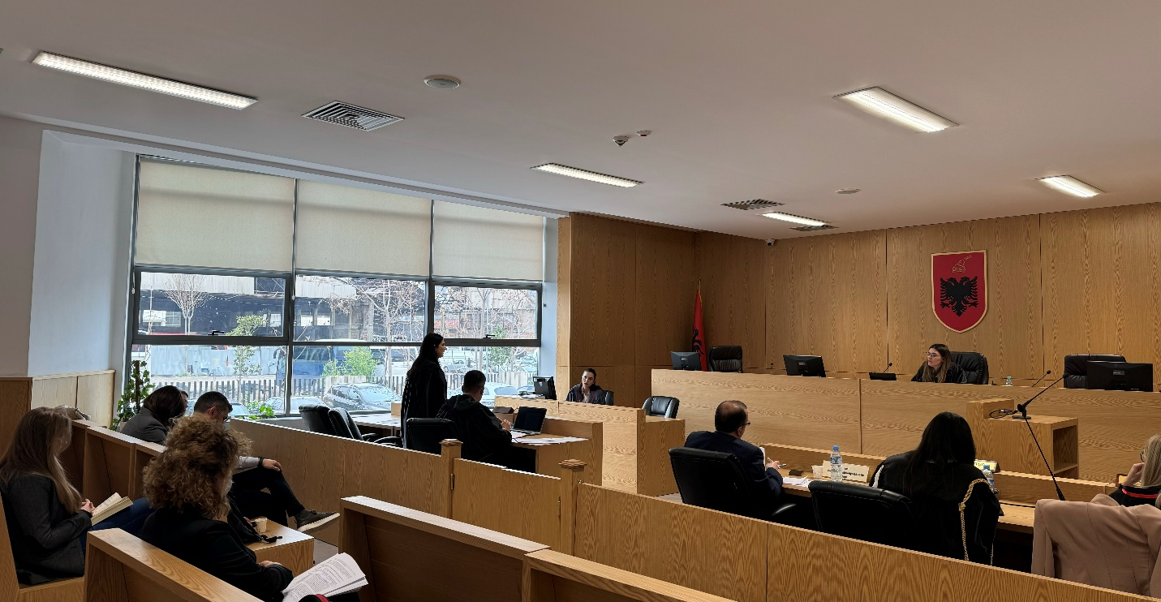
Photo of the mock trial, IInd year

