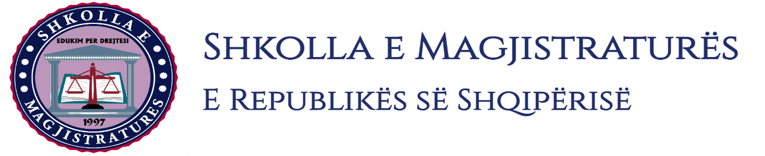
THE SCHOOL OF MAGISTRATES
OF THE REPUBLIC OF ALBANIA

IInd year
2023-2024

CRIMINAL MOCK TRIAL

On 29 January, 2024, candidates for magistrate of the second year, under the mentorship of Prof. Arben Rakipi, organized the mock trial in criminal law. The case chosen by the candidates was:

“The trafficking of war weapons, in the form of exportation,” an attempted offense, accomplished in cooperation, foreseen by the Articles 278/a/2 and 22 of the Criminal Code;
“Production and sale of narcotics” foreseen by the Article 283/1 of the Criminal Code; and “Cultivation of narcotic plants,” foreseen by the Article 284/1 of the Criminal Code.

In this mock trial, candidates for magistrate elaborated different procedural and material issues regarding the preliminary hearing and the judgment of the case on merits. Regarding the preliminary hearing, the discussion was focused on the invalidity of procedural acts, on the uselessness of proofs, on the necessity of obtaining new proofs, the judicial qualification, as well as the accomplishment of the standard of the insufficiency of proofs. Also, by the candidates for magistrate, during the judgment of the case on merits, was discussed on the judicial qualification, competition, the accomplishment of the elements of the consumption of the criminal offenses, referring to the jurisprudence of the High Court, the accomplishment of the standard beyond every reasonable suspicion, permissible readings, etc.

The mock trial, in all its phases, applies procedural rules sanctioned in the Code of Criminal Procedure as well as respected the solemnity of the trial.

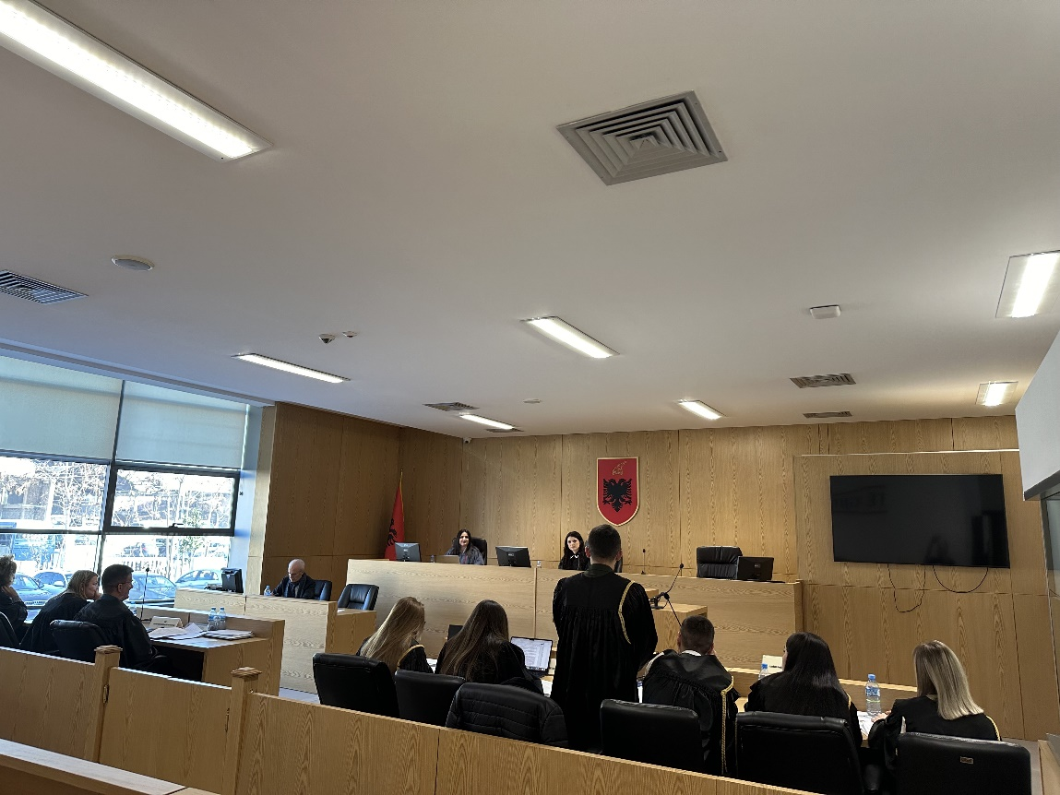
Photo of the mock trial, IInd year

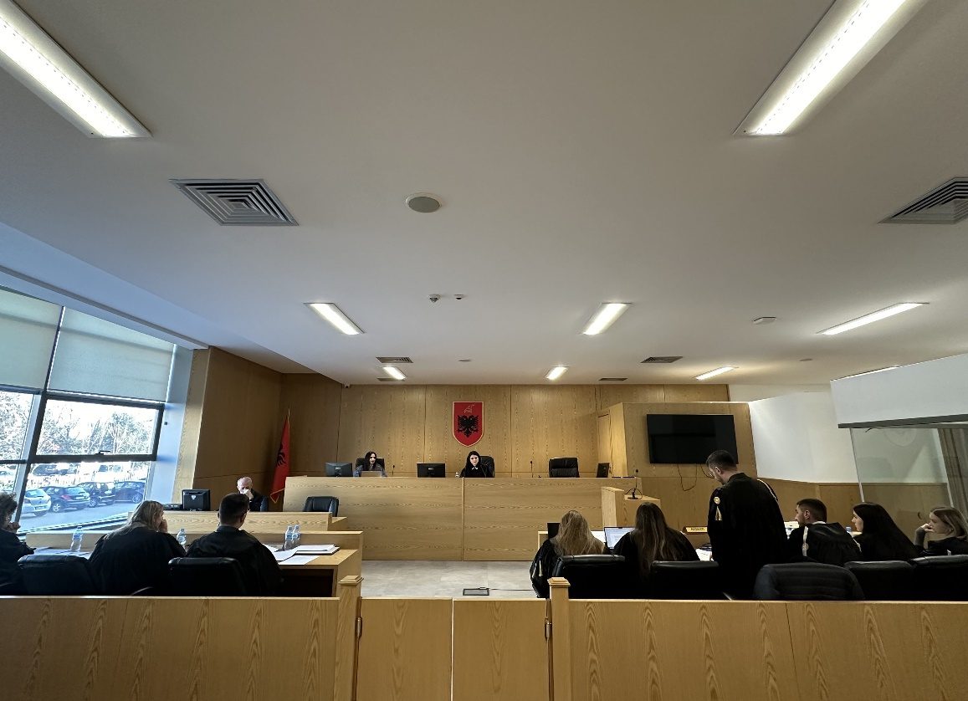
Photo of the mock trial, IInd year

