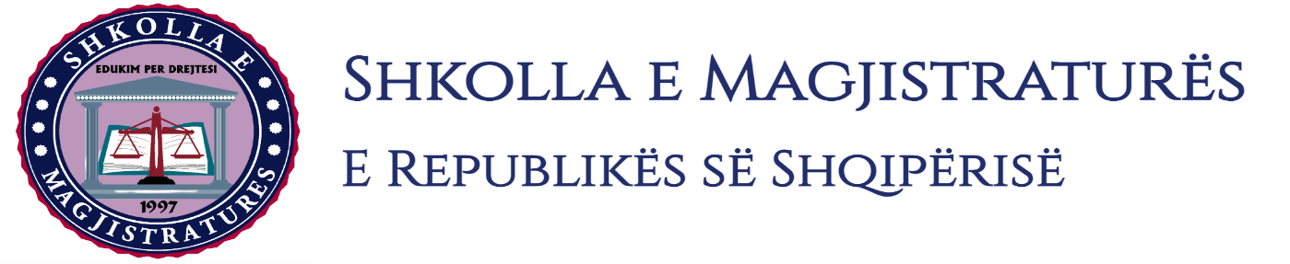

THE SCHOOL OF MAGISTRATES
OF THE REPUBLIC OF ALBANIA

IInd year
2023-2024

CRIMINAL MOCK TRIAL

On 30 October, 2023, candidates for magistrate of the second year, under the mentorship of Prof. Henrik Ligori, organized the criminal mock trial. The case chosen by the candidates was:

“The consideration of arrest in flagrante delicto and the ensuring of the safety measure.”

In this mock trial, candidates for magistrate elaborated legal cases regarding the consideration of the arrest in flagrante delicto and the safety measure.

Candidates assigned to the role of the prosecutor required the consideration as legal of the arrest in flagrante delicto of the suspected persons and the ensuring for them of the safety measures.

The request was opposed by the defense as a violation of criminal procedural rules.

At the end, by the side of the judging body were considered as legal the arrests in flagrante delicto of the suspected persons and was ensured for them the personal safety measure of “arrest in prison.”

The mock trial was subject of all procedural rules foreseen by the Code of Criminal Procedure, and of the solemnity of trial.

